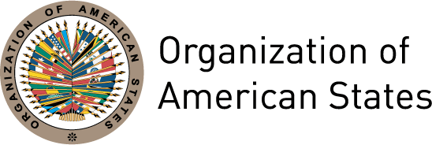

Gender mainstreaming at the Organization of American States

KNOWLEDGE BASELINE AND NEEDS ASSESSMENT

Gloria Bonder and Sophia Huyer

EXECUTIVE SUMMARY

This report is intended to support CIM and OAS in their gender mainstreaming efforts by providing a baseline level of information on staff awareness, knowledge and practice of gender analysis and action in their daily work. It also assesses their needs for training and institutional support to start or strengthen gender mainstreaming in OAS programs.

It was developed by FLACSO within the framework of a consultancy supported by the Canadian International Development Agency (CIDA).

The specific objectives of this activity were to:

- Assess motivation within the institution to integrate gender concepts and tools in its work as well as capacity for gender analysis and action.
- Determine the extent to which OAS Secretariats and Divisions have integrated gender in their strategic and operational planning and programme cycles.
- Identify good practices in using a gender perspective.
- Use this information for developing a series of training workshops on gender mainstreaming.

The methodology employed a mix of qualitative and quantitative methods including a staff e-survey; interviews with key informants (i.e. Secretaries and Heads of programs) from selected departments; and review of key OAS resolutions on this matter. A series of meetings were held with the Executive Secretary and personnel at CIM concerning consultations for the preparation of the questionnaire, selection of interviewees, discussions of interim results, focus of workshops, and other project activities.

The instruments used to gather and analyze data are included as annexes.
The purpose of this assessment was to collect qualitative and quantitative data which reflects the current status for implementing gender mainstreaming in the framework of the IAP in the OAS, and the potential role of CIM to support this. The assessment included three phases: an e-survey of OAS Directors of Departments and Secretariats, including personnel in charge of projects and programs and Directors of OAS country offices, interviews with Secretariat and Division Heads and personnel; and a workshop held with gender facilitators from each Secretariat, and ongoing consultation and assessment of results with the CIM Executive Secretary and personnel.

The specific objectives of this assessment were to:

- Assess motivation within the institution to integrate gender concepts and tools in its work as well as capacity for gender analysis and action.
- Determine the extent to which OAS Secretariats and Divisions have integrated gender in their strategic and operational planning and programme cycles.
- Identify good practices in using a gender perspective
- Use this information for developing a series of training workshops on gender mainstreaming

The scope of this document is limited to the assessment of the current situation of gender mainstreaming in OAS. The report is intended to support OAS and CIM to understand the barriers and opportunities for gender mainstreaming in the Organization as well as short, medium and long-term strategies to integrate gender equality into the Organization in a meaningful and effective way.

The methodology employed a mix of qualitative and quantitative methods including an E-survey of OAS directors and other personnel; interviews with Heads of Departments and Secretariats, Directors, and planning focal points from selected departments; review of staffing data; review of recent IAP reports; and workshop discussions with gender facilitators. The interviews and analyses were carried out by the consultants during the period December 2009 – March 2010. This report is finalized in June 2010.

1. RESULTS OF THE QUESTIONNAIRE

A letter requesting staff to respond to the questionnaire was signed by the Executive Secretary of the CIM and distributed to 198 persons including Directors of Departments that integrate different Secretaries, staff in charge of projects /programs and representatives of national offices

Sixty two responded to the survey. The comparatively low response is attributed in part to the Haiti earthquake which took place just a few weeks before, and which was taking up a considerable amount of time and effort within the Organization. Also, the low response is attributed to the amount of work of the personnel and the habit of not responding to questionnaires which was seen in other surveys.

  - Demographics of Questionnaire Respondents

Of the respondents, 48 were female and 24 were male. The majority of female respondents were 40 years old or younger, while the majority of male respondents were between 41 and 50 years of age.

The majority of respondents hold at least one post-graduate degree. The range of experience is fairly even, as is the range of position. Among women, 47% have been employed for more than 10 years at the OAS, among male respondents, 38% have employed for more than 10 years.

The majority of respondents hold some form of contract position, rather than a full time staff position.

1.2. Assessing knowledge and understanding of gender

To the question, “Are you aware of the OAS gender policy?” (Note that this question refers to the OAS mandates in gender mainstreaming). 61% of the female respondents answered in the affirmative, while 39% were not aware. Of the men, 42% were aware of the OAS gender mandates

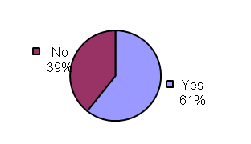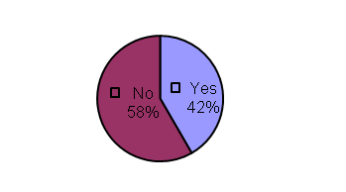

Comments providing a description of some of the main components of the OAS mandates in gender mainstreaming reflect different degrees of understanding of the concept. They ranged from a perspective of equity, or equal numbers, of men and women in projects, activities and staffing, to an understanding of addressing gender issues, trends and opportunities in different aspects of the Organization and its programming. Several comments referred to the importance of equality of representation in decision making in the Organization. The responses of the majority express a good understanding of the mandates.

Despite this, the majority of respondents felt that their understanding of the OAS gender mandates in particular about the Inter-American Program on the Promotion of Women Human Rights and Gender Equity and Equality (IAP/PIA) was “cursory” or “poor”:

Only 4% of female respondents felt they possess “in depth” knowledge of the OAS gender mandates, while 50 and 46% felt their knowledge was “poor” and “cursory” respectively.

Males were somewhat more confident about their level of knowledge, with 17% stating their knowledge were “in depth”, and while 50 and 33% felt it were “poor and cursory”.

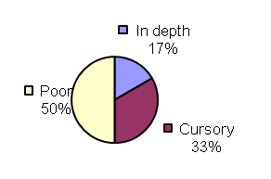

In response to the question, “Which unit/area at the OAS do you think is responsible for developing gender mainstreaming?” a slight majority of respondents understood this to be a responsibility of all units and departments, while many felt it to be the responsibility of a particular group – either CIM or another unspecified unit.

Female:

Male:
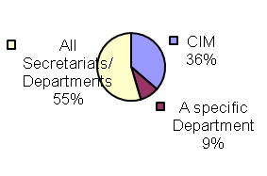

Several felt that in addition to CIM, the Human Resources Department has responsibility for gender equality in the Organization, reflecting a strong perception that gender equality in OAS relates primarily to staffing, workplace conditions and organizational equity issues.

For the question “What is your opinion of OAS´ gender policy?”, respondents were given a range of possible responses and invited to select as many as they felt were applicable.

Female participants demonstrated recognition that the OAS mandates in gender mainstreaming, in particular the IAP, represents a formal agreement adopted by all OAS member states and supported by the Summits of the Americas, and that it should be mandatory for the entire institution. However a greater number felt that the IAP was not strong enough and that it was not adequately implemented in most of the divisions. One respondent statement that mandates are not implemented, particularly those concerning the hiring and promotion of women.

Notably, a substantial number of respondents had no opinion on the OAS mandates in gender mainstreaming, in particular the IAP.

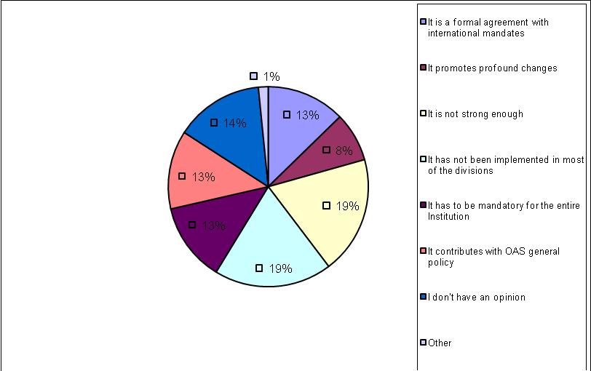

Responses of males reflected a different perspective on the IAP. The strongest comment was the sense that the IAP should be mandatory for the entire institution and secondly, the formal and international nature of the Program. There was less dissatisfaction with the strength of it. It is hard to know the reasons for this difference in perspective. It could be that women feel the lack of implementation of gender policies at a more personal level than men and therefore have a lower opinion of their efficacy.

To the question “What have you always wanted to know about gender and were afraid to ask”, the responses again reflect an overall good understanding of gender equality issues. Gaps are seen in how to operationalize or implement gender equality in programmes, operations, and workplace hiring and advancement; and in tools and support to achieve this.

When asked about their reservations about gender, comments ranged from the perception that gender was just another development trend and the need to set clearer goals, measure progress and analyze obstacles to success. A clear concern among both women and men was the perceived focus on women of the gender equality approach, to the cost and/or exclusion of men and children.One comment referred to the cultural barriers against gender equality which exist in parts of Latin America.

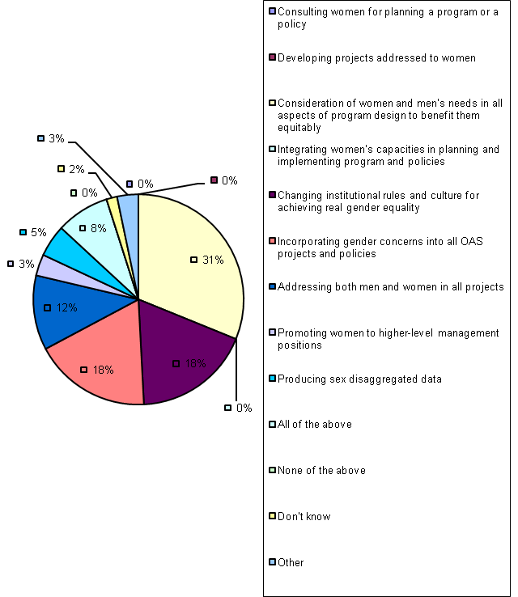

When asked to choose two phrases which define “gender mainstreaming”, “Consideration of women and men’s needs in all aspects of programs designed to benefit them equitably” was ranked at the top,

1.3. Acquisition of knowledge and application of skills in gender analysis and responsive actions

The majority of respondents have received information on gender analysis, either internally or through external sources. 71% of female respondents have received this information, compared to 50% of the male respondents.

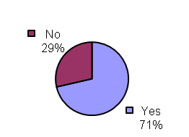

Most received this information through specific training – 64% of women and 50% of men, while “self-learning” came second at 31% (females) and 25% (males). Last was formal education.

For those who engaged in self-learning, the means of attaining this information was equally divided among job experience, books, articles, conversations with colleagues and internet – for both males and females.

For most females, duration of training and / or formal education sessions tended to be primarily in workshop format from 3-7 days, while male experience tended to be up to 7 days. For most respondents, gender training was primarily obtained through the previous CIDA-funded gender training workshops. 25% of female respondents took one or more formal courses, while one male and one female respondent held a degree in a gender-related subject.

Among both male and female respondents, approximately 40% found the training worthwhile, with about equal percentages finding it either excellent or very useful. Comments indicated that respondents felt that the CIDA gender training gave them a good grounding in definitions, understanding and concepts. An expressed need was for more concrete and specific applications of the theory to their work; while some felt that their training had provided them with the tools to move forward on their own, others felt there was a need for more specific information.

Reflecting these comments, answers to the question “What issues or topics were covered in your training or self learning or formal education on gender?”, the top answers among females were “Gender definitions”, “Relevance and use of sex disaggregated data”, and “Gender mainstreaming” at 16%, 13% and 13%. “Gender definitions” came in at the top for males, but perhaps because of the lower number of male respondents, coverage of other issues was evenly spread – with the exception of “Programming and evaluation of gender equality interventions” which was not marked as part of the training or education of any of the male respondents. Among the female respondents, “Application of gender analysis to your field / programs”, “gender analysis” and “gender indicators” came in at 10%, while the rest of the potential responses were at 6% or less.

Females: Males:

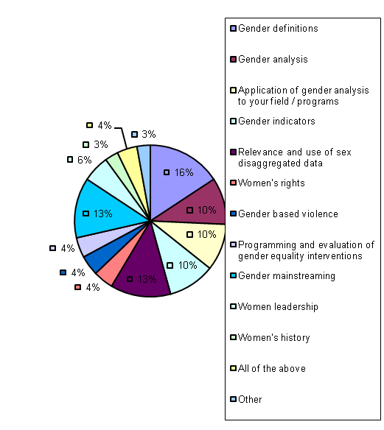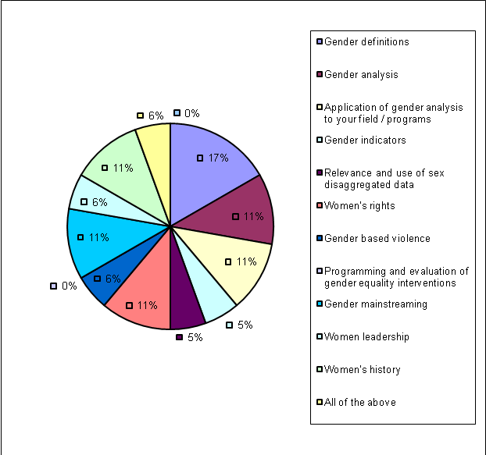

Questions concerning how respondents address or incorporate gender into their work

In identifying the factors preventing gender analysis in their work, men felt more than women that lack of knowledge was the main barrier, while the top reason for females is a lack of tools to help integrate gender into their work. Next level reasons are mixed between institutional lack of support (financial or programmatic) or priority on gender analysis in the division and lack of technical support and tools to integrate gender. Males also felt more strongly than women that there is a lack of appropriate gender evidence or data in their area of work.

Females:

Males:

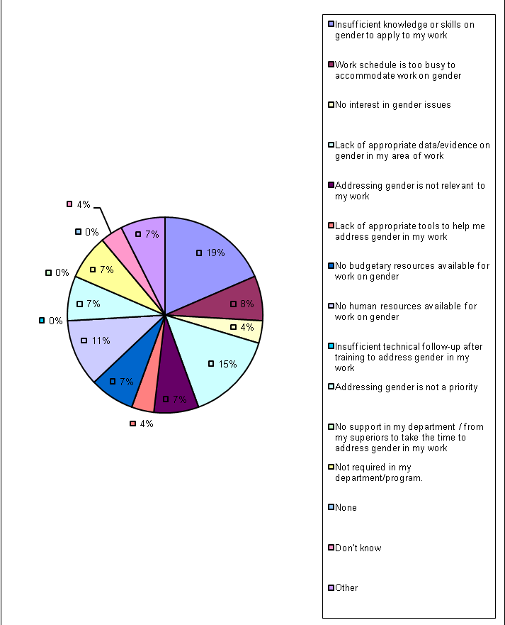

Comments revealed that respondents consider gender to be a low priority for their colleagues, and that there are no accountability mechanisms for the consideration of gender in the work of the Organization. There is also a sense of a low level of political support from the top for achieving the objectives outlined in the IAP.

These issues are addressed more specifically in the next section.

1.4. Institutional support to staff for addressing gender

Among both males and females, the top ranked form of support to address gender in their work consists of “Opportunities to increase my knowledge and develop stronger skills in gender mainstreaming”. This is followed for females by “Commitment from the top levels of OAS”, and for males by “Data/evidence on gender in my area of work” and “Resource materials on gender”. As found in Section 3 above, female respondents allocated equivalent importance to technical resources / support and institutional support and commitment. Males focused more on a need for technical support and resources.

Female responses:

Male responses:

Priorities for gender training were almost the same for both males and females, with “Good practices of gender mainstreaming policies and programs” ranked as the most important, followed by “Gender tools for planning, implementing and assessing projects and programs” for women and “Gender analysis frameworks and methodologies” for males, as second and third priorities. The men also ranked “updated gender theory” quite high, as a second level of priority.

For women, “updated gender theory” was third on the list, followed by “normative/legal resources related with gender equality” which received a comparatively low ranking, by both females and males.

Female responses: Male responses:

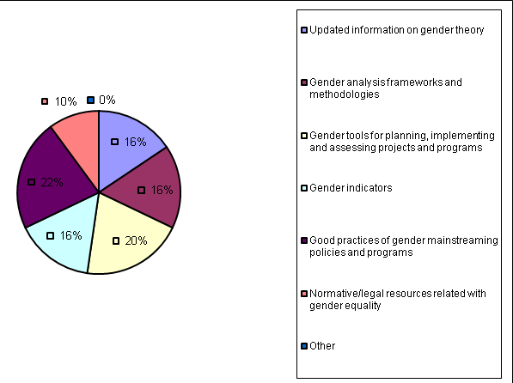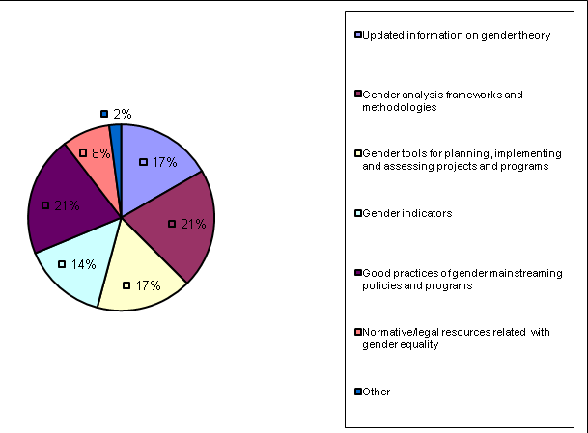

1.5. Workplace and promotion policies

Answers in this section indicate that while gender-responsive policies exist in the Organization, there is a gap in implementation. 61% of females and 67% of males felt that workplace policies are supportive of women’s experience and perspectives, and 50% of females felt that they are supportive of those with family responsibilities (compared to 75% of males). However questions on advancement and opportunities for women received less favorable responses.

Interestingly, this section sees the greatest divergence of opinion according to gender: 46% of females felt that women do not have equal opportunity for advancement, compared to 25% of men. 67% of males felt that women have equal opportunity, compared to 35% of females. In a related question, 58% of females considered that barriers exist to women’s advancement in the Organization, compared to 27% of males. 38% of females considered that there are no barriers to women’s advancement, compared with 64% of males.

The reasons for these barriers are considered to be (in order of importance):
- Women have to be twice as good as men to be considered equally qualified
- “Old boys' networks” continue to exist (a close second)
- Lack of visibility, leadership and mentorship of women in the Organization
- Lack of women’s networks.

The issues of least importance (at 1 vote each) were: Women are penalized for not working overtime; and men are retiring at a later age. Other reasons given were: Lack of commitment among male leadership and lack of trust of women in power.

Female:

Male:

The actions considered most influential in increasing women's advancement to leadership in the Organization by both females and the males who responded to this question are: Implementing transparent and open hiring practices, establishing targets for women in leadership, and encouraging women and minorities to apply for all open positions.

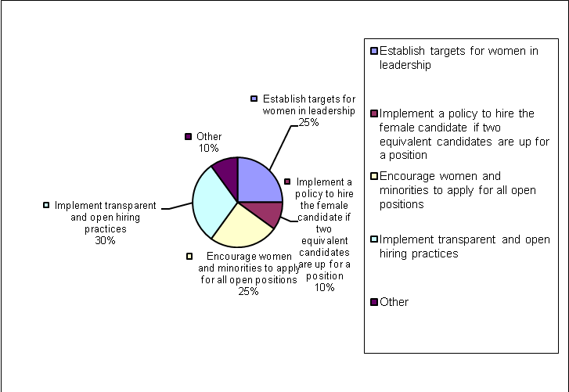

Comments also included a suggestion for a women’s support network to encourage the professional development and advancement of younger women, benefitting from the experience of their peers.

1.6 Conclusions

Overall, some of the conclusions to be drawn from the questionnaire are:
- There is a quite high level of acceptance of gender and organizational responsibility for gender, based on the previous set of gender workshops and efforts made by staff to learn more about gender equality in their work.
- There remain questions among some staff about whether a “gender” approach is really an excuse to focus on women to the exclusion and/or detriment of men and children, which indicates that not all staff really understand the concept of “gender equality” or perhaps that some feel threatened by this approach. There is also a lack of awareness of the evidence and data to support gender equality arguments and the fact that some actions can be taken as a starting point without a large base of quantitative data.
- Most staff feel the need for resources and support on the more practical aspects of implementing gender equality perspectives and strategies in their daily work and the work of their division.
- While there is a strong framework of mandates in gender in the Organization which provides a good basis for moving forward, there appears to be a lack of systemic institutional support, resources, understanding and motivation to integrate and maintain gender equality into the work of the OAS, starting from a lack of clear commitment at the top.
- While the previous gender training sessions were considered valuable, a lack of follow up and moving around of personnel meant that there was not as much progress in mainstreaming gender in the activities of the Organization as there could have been. However it is also clear that some participants value these sessions and have worked hard to implement what they have learned in their work.
- Many feel that there are strong gender barriers to advancement in the Organization, and unaddressed gender issues in the workplace. There is a need to understand at a deeper level why these barriers persist in the Organization, and what level of commitment and action to gender goals is desired and achievable.

2. INTERVIEWS

The consultants engaged in a series of interviews on December 8, 2009, and February 15-17, 2010, with key personnel in the different divisions. A list of interviews is attached (Appendix x).

During the course of the interviews, division representatives were asked a series of questions:
- How is your division / department/ Secretariat integrating gender into its activities?
- What kind of gender support or technical expertise do they need, from any source?
- What needs to be done in the OAS overall?
- What is the role for CIM?

A number of main issues around gender at OAS emerged, many of which were echoed in the results of the questionnaire. The key issues identified are:

- In general, there is quite a high level of knowledge of gender equality in the Organization. Staff are gaining it either through formalized training, through self-learning, or through experience in their day to day work. There is a strong policy mandate in both the IAP and in other OAS Resolutions.

However, the lack of institutionalization of the IAP is a key barrier to gender mainstreaming of the Organization. Even those personnel who are highly committed to integrating gender note that there is a lack of resources, time and lack of support for their work. There is a need for senior management to demonstrate a strong support to gender mainstreaming and to gender equality at all levels of organizational policy, in program design and implementation, and in the workplace setting.

The IAP is neither well known nor used in the Organization, and there is a gap in implementation of the IAP and in supporting the integration of gender into the OAS and its programmes. There is a sense the mandates outlined in the IAP are not well known, supported, or institutionalized. Even staff who are committed to the issue often find a lack of resource, time and management support for their work. There is need for stronger institutional and managerial support for the gender mandates in the Organization. Staff should be encouraged to address gender equality issues in their work, and provided the resources and support to accomplish this.

To address this, top level management needs to demonstrate commitment to the IAP and provide an atmosphere where integrating gender is considered an important part of the work of each division and an integral part of job performance. Senior management needs to demonstrate strong support for mainstreaming gender and gender equality considerations into all levels of policy, programming and workplace organization.

- Related to this point, there is little understanding among many in the Organization of why it is important to incorporate gender concerns in the OAS. Personnel at all levels, from the top down, need to be educated on the importance of the issue for social democracy and equality, as well as how it will improve overall outcomes and increase results of the work of all divisions in the Organization if the gender implications are understood and taken into account.

- A common theme expressed in interviews was the need for technical expertise, guidance and help in learning how gender equality issues apply to the work of the divisions, and how GE can be mainstreamed into the work of the division: “we are all convinced but we don’t know how to do it”.

It was mentioned in one interview that while some divisions and programs are incorporating gender into their work effectively, they often feel that they are doing it on an ad hoc basis, i.e. that they are learning about gender issues as they come across them in their work. Many are looking for a way to systematize their knowledge and fill in gaps, and to have access to information or guidelines on systematized monitoring, benchmarking and indicators in their activities.

- The need to monitor, measure and reward gender results was also a strong theme, in terms of performance review of staff, as well as programme assessment and evaluation. It was suggested that gender “success” and advancement of the issue as well as of diversity in the workforce in the organization should be recognized and rewarded.

- There are some excellent examples within the organization of how gender equality concerns can be successfully integrated into the work of a division or a project, and how it can contribute to increased results. Work with the Ministries of Labour and gender machineries in the region, PUICA, and the work of the Summit of the Americas with civil society groups are valuable examples. These best practices are not as well known inside the organization as they could be, because of a lack of communication between divisions, a lack of exchange of information on lessons learned, resources, and strategies. These examples are not shared with other divisions as much as they could and should be. The reasons for this should be examined more closely: gender mainstreaming also involves addressing contextual and institutional factors and traditions which limit learning in an organization.

- A number of human resources and workplace issues emerged, both during the interviews and in the course of the workshop with the Human Resources Department.
- Concerns were expressed that upward mobility in the institution is difficult for both men and women, and in particular for women, who often have trouble breaking into the “old boys’ club” at the top.
- Data analysis done by the Staff Association indicates that women tend to be clustered at the lower levels of the organization, and have trouble breaking through to the top.
- Workplace safety and security was listed as a problem by some, including harassment and discrimination.
- There are concerns about a lack of transparency in hiring, advancement and job performance evaluation.
- Other concerns expressed include
  - Absence of equal pay for equal work
  - Men are not sensitized to women’s issues
  - Isolation of women managers
  - Need for gender balance at all levels, which may involve hiring more men for clerical and administrative support positions.

Despite these concerns, a number of divisions are integrating gender equality into their work very effectively

- The Summit of the Americas office has a strong practice of collaboration with civil society groups and integration of civil society into hemispheric policy. Through its work with women’s groups, gender equality issues have been incorporated into all Summit Declarations, and civil society groups have been brought to the Summits, with gender balance in representation. Women are represented equally in SAS stakeholder groups.

SAS is also in the process of implementing an online monitoring system for Fifth Summit follow up: SISCA. Formally launched by the Secretary General in January, it is being introduced and launched in the region to facilitate input to the June General Assembly. It organizes by paragraph and category all the major mandates in the Summits. Two mandates focus specifically on gender equality, with a strong focus on education, labor, politics, maternal health. AS well, the MDGs are taken as the main framework, with gender equality as a cross-cutting issue.

- The Department of State Modernization and Good Governance

The Civil Identity Program of the Americas (PUICA) regularly collects sex-disaggregated data, monitoring the participation of women in its programmes as well as the representation of women in beneficiary groups. 70% of the 4.2 million persons who were registered in a national program in Haiti were women. The project has also provided job opportunities for 1,000 women who worked in the mobile campaigns and the keyboarding historical records, among other processes (40% of those hired). It has also worked at the national level, with work on reforming the legal framework that governs the Registry Office (vital statistics bureau). Proposals for reform include a law that does not discriminate against women, making it possible for them to call for the effective enforcement of their right and the right of their children to a civil identity.

PUICA also worked with indigenous groups and indigenous women through registry initiatives in remote areas, where under-registration is common among girls and women. In three months, the RENAP registering 250 persons in 90 communities in Chichicastenango, with more than 80% of these being women. Its work on hospital registration systems in maternity wards in El Salvador so that mothers can register their children in hospital facilities hours after childbirth. This substantially facilitates service by not requiring additional travel, in addition to ensuring that the right to an identity is effectively enforced for thousands of children born every year. The project has also been an opportunity to detect those mothers who have no civil identity and to instruct them about how to do a late registration.

- Department of Social Development and Employment (DSDE)

CIM has been working with DSDE since 2001 towards integrating a gender perspective within the agenda of the Ministries of Labor in the region. The DSDE recently conducted a study on the institutionalization of the gender perspective in the region’s ministries of labour, as well as with the different bureaux, units or commissions dealing with gender within each ministry. The purpose of the study was to give the Inter-American Conference of Ministers of Labor (IACML) an overview of the progress in this area, identifying strengths and weaknesses as well as remarkable results, with the overall goal of defining strategic areas of intervention in particular through the Inter-American Network for Labor Administration (RIAL).

This project is an extremely successful example of collaboration with governmental institutions.

Questionnaires were sent out to Labor Ministries as well as national mechanisms for the advancement of women. Key informant interviews were held in a number of countries, and research into secondary sources and case studies also took place.

The information received was mapped and analyzed, supplemented by desk research and interviews. The resulting report looks at the context for integration of gender into Labor Ministries; an institutional map of gender bureaux within ministries of labor in the region, as well as an organizational analysis of gender bureaux in terms of location in the ministry, resources, activities, function and stakeholders. It identifies gaps between policy and action, strengths and weaknesses and sustainability of function. The report concludes with a set of recommendations and assessment of best practices. The preliminary report was presented to delegates from national labor ministries for discussion of findings. At the XVI CIMT, held in September 2009 in Buenos Aires, Argentina, the study was officially presented and agreements reached on the actions to follow to continue consolidating the gender perspective inside the Ministries of Labor of the region, with support from DSDE and CIM.

Throughout this process the DSDE worked closely with CIM, which provided technical expertise, connections to national machineries at the country level, helped develop the questionnaire and helped to connect the Ministries of Labour with the women’s machineries. The Department also worked closely with external agencies with a great deal of expertise in related areas, such as the ILO and ECLAC.

These relationships present an excellent model for collaboration in other areas of the OAS.

3. RECOMMENDATIONS

Recommendations are presented here both for the OAS as an Organization, and for CIM within the OAS.

3.1. Recommendations for the OAS

- The OAS should continue to support the work of the Department of Planning and Evaluation to organize tools and processes to systematize gender assessment into the entire project design, planning, implementation and monitoring and evaluation cycle. For example, it should:

  - Monitor gender balances in scholarship; student loans; training programs, including applications as well as awards.

  - Mandate a gender assessment of every program/project

  - Undertake an assessment of how mechanics of integrating gender can be improved

  - Develop a set of benchmarks and indicators for each program and sector to measure the degree to which gender equality concerns have been integrated and GE goals have been met.

  - The top levels of management and leadership need to take on, commit to and promote gender mainstreaming in the organization.

  - A larger-scale assessment should be undertaken of what does the Organization need in terms of GE support; and what do each of the different divisions need to do to mainstream gender more effectively. The goal of such an activity should be to take a more qualitative approach to capture staff views on which obstacles to gender mainstreaming in the organization should be addressed, which strategies have been successful and why, how they envision gender equality in their work, if they perceive limits in the organization and which strategies should be taken to address it .

  - Sponsor discussions on why different divisions should focus on women and gender. How and in what way will /can the involvement of women in OAS activities move it and the Hemisphere forward?

  - Organization-wide activities can be organized to promote gender equality and implement innovative ways of getting staff to understand gender roles and issues in a different way. Off-site retreats could be organized, or shorter term activities such as organizing a role reversal exercise for a half day between male managers and female staff; or female support staff and those they provide support for. Developing leadership training sessions for how men can work with women leaders; and ensuring gender balance in leadership sessions for younger staff.

  - One key suggestion is to organize a group of all women in high positions in OAS to work together on topics such as management ethics, leadership and others. That group could have regular meetings with the Secretary-General to discuss priority issues. It could also invite leaders from different areas such as politics to discuss gender issues and leadership in the organization.

  - Create a forum, platform or opportunities for women leaders in OAS which will promote systematic sharing and comparison of project advances, progress and successes. Experts could also be invited to speak to this group on specific topics relating to gender in the organization. These activities could help to create a lively and engaging support environment for gender mainstreaming.

3.2. Actions for CIM

In general, a strong message emerging from the interviews is that CIM is not well known or recognized within OAS, that it is somewhat isolated. It is seen primarily as a body that works outside of OAS – a political body working with government machineries. Its profile tends to be low within the Organization, so that it is not providing the gender mainstreaming expertise to the OAS that it could; and its work does not get the recognition or publicity it deserves. It is also considered that this isolation has caused it to be out of touch with the rest of the OAS in terms of its priorities, approach and programming.

One of the questions for CIM is whether it wants to continue in this mode, or expand its links with the OAS and its activities with OAS divisions. This also needs to be made clear to the divisions. The CIM mission needs to be clarified and communicated to all sectors in OAS, so that everyone understands what kind of support the divisions can expect and what the role and function of CIM is.
A clear message is that CIM needs to “develop and make known a raison d’etre” which is updated and part of the current OAS priorities and strategies. Others noted that while CIM has been pioneer in OAS, its discourse is “old fashioned…. They need to change and resell the image of CIM. It was pioneer and it has to continue being a pioneer, but for doing that it that has to renew its discourse."

Other general recommendations include developing a strategy for support to departments on gender mainstreaming and addressing working conditions and workforce issues in the organization. Gender barriers in the work of the Organization are considered a very serious issue, and a role of OAS should be to find a way to match rules and policy to day-to-day practice in a systematic and long term strategy.

And finally, many of the OAS divisions are already successfully integrating gender equality into their activities and developing effective projects around the gender equality implications of their sector. CIM needs to think carefully about how it can best coordinate and collaborate to spread these various activities across the organization.

Under these overarching comments, recommendations for CIM are grouped into three categories:

- Actions CIM can implement at the existing level of resources, or with a small increase.
- Actions CIM can accomplish in collaboration with other departments in the OAS
- Actions for CIM with an increased level of funds or other resources.

- Recommendations that can be implemented at the current level of resources

- CIM should develop a Strategic Plan in collaboration with other divisions to define its priorities vis a vis the OAS and its member states as well as work in specific areas or on specific projects.

- There is a strong need for technical support and access to technical resources in the Organization. CIM should build a web-based data base of resources including publications related to all divisions, web links, good practices both within OAS and other organizations.

- CIM needs to contribute to sensitization to gender in all sectors of the organization. One strategy to do this is to develop a set of evidence-based materials and arguments on why gender equality is important, for each division and/or programme of the Organization. These materials need to explain the major impact of women in the mains areas and priorities of the OAS, what women contribute in the sector or area, why they are important, what will be accomplished by including women and gender equality in programs, and what will be the gaps and disadvantages if women and gender equality are NOT addressed.

- It can organize regular meetings in which divisions can exchange information about their work, provide peer mentoring and discuss current problems and issues which they come across.

- CIM could distribute an Internal newsletter or listserv on women and gender to:
  - Provide information on activities of other organizations in the region
  - Provide updates on gender issues related to the organization and its work
  - Assess statistics availability and undertake outcome analysis
  - Connect departments with information relevant to their priorities.

- Present a monthly or yearly award or some form of recognition to a division and/or individual staff member who shows leadership in mainstreaming gender.

- CIM should use its leverage and connections with high-level political leaders and ministries to continue to highlight the leadership and contributions of women in various sectors. Several potential activities and collaborations were suggested:

  - In collaboration with the Human Resources Department, organize a meeting with Secretaries and Heads of divisions to meet with women’s ministries and explore how to work together.
  - Promote a Blue Ribbon Panel of high profile women leaders to mentor women in the organization and create funding opportunities for CIM.
  - In collaboration with, take advantage of the presence of high-profile or political women leaders in Washington to hold seminars and panels promoting regional gender issues.
  - Based on CIM’s work with DESDE on labour, a useful role for CIM could be to promote gender awareness in public and policy forums on the different areas of OAS focus.

- Collaborations:

2.1) With the Human Resources Department:

A very clearly expressed concern throughout the Organization is the lack of women in senior management positions and what is seen by many as a resulting male-dominated “macho” culture. Recommended activities to redress this gap include providing career and leadership training to women in middle management, identifying “high potential” women and men for support and training to advance in the organization, assessing barriers for women in the Organization, and providing gender sensitivity training on appropriate workplace interaction to both women and men.

A workshop was held with the Human Resources Department on February 18-19, 2010, which addressed these and other workforce issues in the organization. A consensus emerged on the key leverage points that the department could work to affect. The priority was agreed to be getting more women into senior management positions in the Organization. Agreed activities to support this goal are:

- Track statistics and indicators disaggregated by sex and geographical diversity and give credit in the organization for divisions and units which demonstrate diversity. A letter from the Secretary-General could be sent to those individuals and divisions which demonstrate success in integrating women and/or gender concerns.
- A major activity is to undertake a study on the status of women in the OAS and what’s needed to support women’s career development. The study will make use of statistics, interviews and focus groups.
- Identify high-potential women for training and support, with a goal of facilitating their advancement in the Organization.
- Promote and facilitate mentoring within the OAS among women.
- CIM can work with senior management in the division to reach and convince the Secretary-General of the importance of implementing steps and providing support to women to advance to leadership positions.
- Co-organize with CIM and the Staff Association on training and other support activities.
- Develop a communications strategy to prepare and present an argument about gender balance within the OAS
- Develop a Website and internal communications on these issues.
- Ensure all OAS policy and program documents contain gender-neutral language changes
- Provide gender awareness training for staff
- Present a gender mainstreaming program/plan of action to the Secretary General and Secretariats
- Hold a high-level Women’s Forum at the OAS.

  - PUICA

The work of PUICA in targeting women as beneficiaries of its programmes and its work towards gender balance in all its activities is very impressive. Its experience is a model for other divisions, and lessons learned and questions arising from its work in gender mainstreaming could be an useful resources for the OAS.

One of the suggestions made by PUICA was to work with CIM on systematizing and furthering its gender work, and to help it fill the gaps in its approach. It suggested organizing a workshop with staff from the field (using video technology) which would focus on the gender issues they deal with in their work and identify key gender points of intervention (i.e. how and where to find women to register; how to work with male leaders of community groups, etc.). The group would be able to brainstorm and discuss solutions and strategies to identified issues and problems staff in the department and in the field encounter.

One pilot project could be established in a country/sector/project as a case study on gender equality approaches and analysis, including development of tools and guidelines, on targeting women for registration and electoral participation, for example, identifying factors which determine why they are or not registering. There is also a need for training on the international legal frameworks which affect their work, especially at the country level. It would also be useful to work with them on how to bring gender concerns into their discussions with government departments when they identify where and how to register people.

  - Summit of the Americas

The SAS Secretariat has offered to collaborate with CIM on a pilot project to work jointly with another OAS department to reach external groups. CIM could provide support to the SAS in terms of technical expertise, statistics, definition of key issues, etc. CIM could also take the role of multi-stakeholder broker and work with both governments and civil society to bring the groups together.

One potential activity is to generate joint civil society –CIM projects on Summit follow-up or other key issues and regional mandates. A first step on this could be to convene a multistakeholder panel to discuss key issues – SAS has a small amount of funding for this activity, which could be used as a step towards a larger high-level forum (see next section). In fact, CIM worked jointly with the Summits Secretariat in the preparation and implementation of a virtual forum on gender issues within the framework of the Fifth Summit of the Americas.

- Activities requiring a greater level of funding

With a larger budget or increased staff, CIM could:

- Provide ongoing input and technical support on as as-needed basis to the division of OAS in the for of advice, inputs on project planning, development, implementation and monitoring, and orientation to different departments. This could be done by internal staff, or on a periodic basis with consultants.
- Explore collaboration with other divisions using the model of the DESDE Labour project.
- Organize with SAS a hemispheric high-level forum to exchange ideas and views between governments and civil society.
- Reward and/or recognize programs or divisions that are consistently implementing a gender mainstreaming approach in programs.
- Create and manage a community of practice on gender mainstreaming both within the OAS and with collaborative partners outside the Organization.

4. CONCLUSIONS

1. Key Findings:

1) The surveys and interviews revealed several major types of gaps:

- Between knowledge and actual application regarding the promotion of gender equality in the work of OAS; and second, between headquarters and countries
- Gender integration in key program documents and strategies, and sex parity among professional staff. There is a marked unevenness within the organization concerning integration of gender mainstreaming in programmes and divisions
- There was a significant lower response from senior personnel to the e-survey

2) The planning phase is the most strategic leverage point for gender integration within the programming cycle process. “Genderless” implementation and evaluation, particularly the latter, are linked to genderless indicators, guidelines and situation analysis at the planning stage. The absence of official feedback and, particularly, the perceived lack of accountability regarding gender integration were highlighted as critical challenges throughout the programming process. Clearly, gender integration in the accountability processes of monitoring/evaluation was deemed the weakest phase of the cycle in OAS. The work of the project and planning division to remedy this gap should be supported at the highest levels.

3) The wide variation in the use and promotion of gender analysis and mainstreaming in programming and divisional structures reflects the varying degrees of gender integration in the managerial and technical work of the different regional units and country offices.

4) Overall, the results of this assessment indicate that awareness and even “knowledge” of gender mandates and concepts--as transmitted through one-time workshops or a set of tools and guidelines--, seemed to act as “entry points”, for some personnel on an individual basis, but not as drivers of gender mainstreaming in the institution. Sustained and tailored technical collaboration are needed to build and apply knowledge that emphasizes the use of gender integration tools and approaches at every phase in the project cycle and every level of the organization.

5) Most importantly, the results confirmed that while knowledge is obviously necessary, the commitment and active support of managers is essential to drive the mainstreaming process and ensure its sustainability and accountability.

Implications of the Key Findings for OAS and CIM:

A strong message coming out of the assessment is that many OAS staff feel that the institutional culture of the Organization can be difficult for women staff to navigate. On the programming side, many staff who would like to actively work towards integrating women and gender concerns into the programs they are involved in, feel that the organization does not support them in these goals.

An important first step for the Organization, then, is to work to support female staff in their positions and to provide the range of support activities and incentives needed within the OAS to encourage gender balance at all levels of the Organization: to see more women in senior decision making levels and more men at levels where they are poorly represented. This requires support for and works with both women and men, at all levels of the Organization.

Achieving the goal of increased gender balance in the Organization will go a long way towards achieving OAS’ gender equality goals. However, if the goal is to integrate gender equality more strongly into the Organization, gender balance of personnel and decision making is insufficient in itself. OAS also needs to develop and implement new and existing procedures and practices for integrating women and gender equality into all of its programs throughout the entire design, development, implementation and evaluation cycle. Some divisions are successfully developing innovative and valuable approaches to gender equality and OAS should expand the experience of these programs throughout the organization.

CIM has potentially a substantial and influential role to play in supporting OAS in both of these types of gender activities, by providing connections to high level women in the region and supporting steps taken in the Organization to promote women and encourage their leadership. It also has a depth of skills and expertise that it can contribute to OAS to increase its ability and knowledge concerning how to integrate gender equality into the entire cycle of its operations.

ANNEX I

INTERVIEWS

List of OAS Staff in Technical Areas

      - Amb. Alfonso Quiñonez, Executive Secretariat for Integral Development (SEDI)
      - Jorge Saggiante, Department of Economic Development, Trade and Tourism of SEDI
      - Pablo Gutierrez, Department of Electoral Cooperation and Observation, Secretariat for Political Affairs
      - Raúl Alconada, Department of Sustainable Democracy and Special Missions, Secretariat for Political Affairs
      - Graciela Piedras and Pilar Hughet, Inter- American Telecommunication Commission
      - Rosa María Barreiro, Department of Human Resources, Secretariat for Administration and Finance
      - Luis Toro, Department of International Law, Secretariat of Legal Affair
      - Jean Michel Arrighi, Secretariat of Legal Affair
      - Cletus Springer, Department of Sustainable Development, SEDI
      - James Mack, Inter-American Drug Abuse Control Commission, Secretariat for Multidimensional Security,
      - Jane Thery, Department of Strategic Partnerships and Relations with the Host Country, Secretariat for External Relations
      - Amb. Adam Blackwell, Secretariat for External Relations
      - Amb. Jonny, Secretary, Summit of the Americas
      - Marie Levens, Department of Human Development, Education and Culture, SEDI
      - Amb. Frank Almaguer, Secretariat for Administration and Finance
      - Irene Klinger, Department of International Affairs, Secretariat for External Relations

. This reflects a lack of understanding of “gender equality” among some staff, who continue to conflate it with promotion of women. Highlighting examples of male as well as female disadvantages and barriers could be one way of overcoming this misconception.
The report is available at: http://www.sedi.oas.org/ddse/documentos/TRABAJO/INF2%20ESP%20(GENERO).doc

