**TENTH REGULAR MEETING OF THE** OEA/Ser.W/XIII.6.10

**INTER-AMERICAN COMMITTEE ON EDUCATION** CIDI/CIE/doc.5/24

November 7 and 8, 2024 28 October 2024

Washington, D.C., United States of America Original: verbatim

Virtual meeting

PROCESS OF BUILDING AND IMPLEMENTING THE WORK PLAN OF   
THE INTER-AMERICAN COMMISSION ON EDUCATION (PTCIE)

2022-2025

Methodology established by officers of the Inter-American Committee on Education (CIE)

(Document prepared by the Technical Secretariat   
at the request of the Officers of the CIE)

**CONTENTS**

A. PURPOSE 1

B. BACKGROUND 1

C. THE BUILDING PROCESS: OPPORTUNITIES FOR DIALOGUE AND COLLABORATION IN THE DECISION-MAKING PROCESS 2

D. ESTABLISHED METHODOLOGY FOR PTCIE IMPLEMENTATION 3

E. DISTRIBUTION AND CONSIDERATION OF PROPOSED DOCUMENTS PRESENTED DURING THE REGULAR MEETING OF THE CIE 5

F. ANNEXES: TIMELINES 5

PROCESS OF BUILDING AND IMPLEMENTING THE WORK PLAN   
OF THE INTER-AMERICAN COMMITTEE ON EDUCATION (PTCIE)

PERIOD: 2022-2025

# PURPOSE

The purpose of this document is to present to the officials of the ministries of education of the member states a summary of the process carried out since the last meeting of the Ministers of Education held in November 2022, which describes different phases of the process of collective construction of the 2022-2025 PTCIE as a mechanism to respond to the commitments and priorities defined in the 2022-2027 Inter-American Education Agenda. This document summarizes the various ways in which the member states participated during the aforementioned period.

# BACKGROUND

During the XI Inter-American Meeting of Ministers of Education held virtually in November 2022, the Ministers adopted the "Hemispheric Declaration on Education" [CIDI/RME/DEC. 1/22](https://scm.oas.org/IDMS/Redirectpage.aspx?class=V.14.1.CIDI/RME/dec&classNum=1&lang=e) “Towards Building a New Educational Hemispheric Pact in Contexts of Change”. During the sixth plenary session held on November 11, 2022, the [*Inter-American Education Agenda 2022-2027*](https://scm.oas.org/IDMS/Redirectpage.aspx?class=V.14.1.CIDI/RME/doc&classNum=6&lang=e) was adopted “*so that the priorities and thematic areas established therein become products and concrete actions for implementation in the 2022-2025 Plan of Action and the Work Plan of the Inter-American Committee on Education (CIE)."*

At that same meeting, the *CIE* was "*mandated to implement the 2022-2027 Inter-American Education Agenda with the support of the Working Groups that were established in accordance with the prioritized mandates for the development of the IEA"...*expanding *"the collaborative work carried out to date with the objective of optimizing the countries' capacity to generate opportunities and promote the continuity of education for all within the framework of the Hemispheric Proposal of Action for the Continuity of Education (PHACE)."*

Following the guidelines established by the member states for [ministerial processes](http://scm.oas.org/IDMS/Redirectpage.aspx?class=cidi/doc.&classNum=228&addendum=1&lang=e), the CIE proceeded with the development, negotiation, and adoption of the [2022-2025 CIE Work Plan](https://www.oas.org/en/sedi/dhdee/CIDED00318E02.docx)  (PTCIE), an instrument that was approved by the Committee on Partnership for Development Cooperation Policies of the Inter-American Council for Integral Development (CIDI) during its regular meeting held on June 6, 2023 (and its revised version on June 14, 2024), through a process of dialogue among officials of the ministries of education.

The Work Plan presents the Hemispheric Programs, initiatives, and actions needed to implement the [Hemispheric Plan of Action on Education "Towards Building a New Educational Hemispheric Pact in Contexts of Change](https://scm.oas.org/IDMS/Redirectpage.aspx?class=V.14.1.CIDI/RME/doc&classNum=8&lang=e)"(CIDI/RME/doc.8/22 rev.1) adopted at the Eleventh Inter-American Meeting of Ministers of Education in 2022, a document in which the Ministers of Education established the priorities and thematic areas for inter-American cooperation and the coordination of efforts to guarantee the right to education.

# THE BUILDING PROCESS: OPPORTUNITIES FOR DIALOGUE AND COLLABORATION IN THE DECISION-MAKING PROCESS

Collective reflection and agreement on actions to be undertaken focused on two priority areas: 1. Systemic approach for building resilient education systems; and 2. Intersectoral agenda. These priorities, with their respective thematic areas, served to provide a framework for all the actions derived from the 2022-2025 Work Plan.

The process of building the CIE Work Plan began with the convening of the Ministerial Process Authorities’ Planning Meeting held on February 9, 2023. There, an opportunity was offered to all the ministries of education that wished to take part in the process of defining the Hemispheric Programs that would embody the mandates issued at the meeting of ministers.

After three months of work, with biweekly meetings of the officials responsible for the ministries of education, the first draft of the PTCIE was presented through a virtual discussion session *(Road Show*) to the rest of the countries that had not had the opportunity to play an active part in developing it.

Reaffirming this process of collective construction of the Plan based on the opportunities for dialogue generated in the process of defining the 2022-2027 IEA, the officials of the participating ministries of education contributed specific perspectives on the subject and, at the same time, pointed out specific challenges and/or needs that were not fully reflected in the hemispheric programs.

The final version of the Plan to be approved by CIDI's Committee on Partnership for Development Cooperation Policies was presented and approved by the CIE Officers (Argentina and Ecuador) and its working groups (Colombia, Guatemala, and Suriname) with the support of the Ministries of Education of Chile, Costa Rica, Jamaica, Paraguay, Peru, and the United States.

The Inter-American Education Agenda (IEA) is guided by the principles of collaboration, intersectoriality, and interculturalism.

Based on these principles and with the view to continuing to enrich the construction process within the hemispheric programs of the Work Plan, 88 contributions were received from the ministries of education. These contributions cover existing initiatives in their countries, such as public policies, programs, research, publications and/or tools, and relate to the two priority areas of the IEA: 1) A systemic approach for building resilient education systems and 2) an intersectoral agenda.

The following opportunities for dialogue were established during this process:

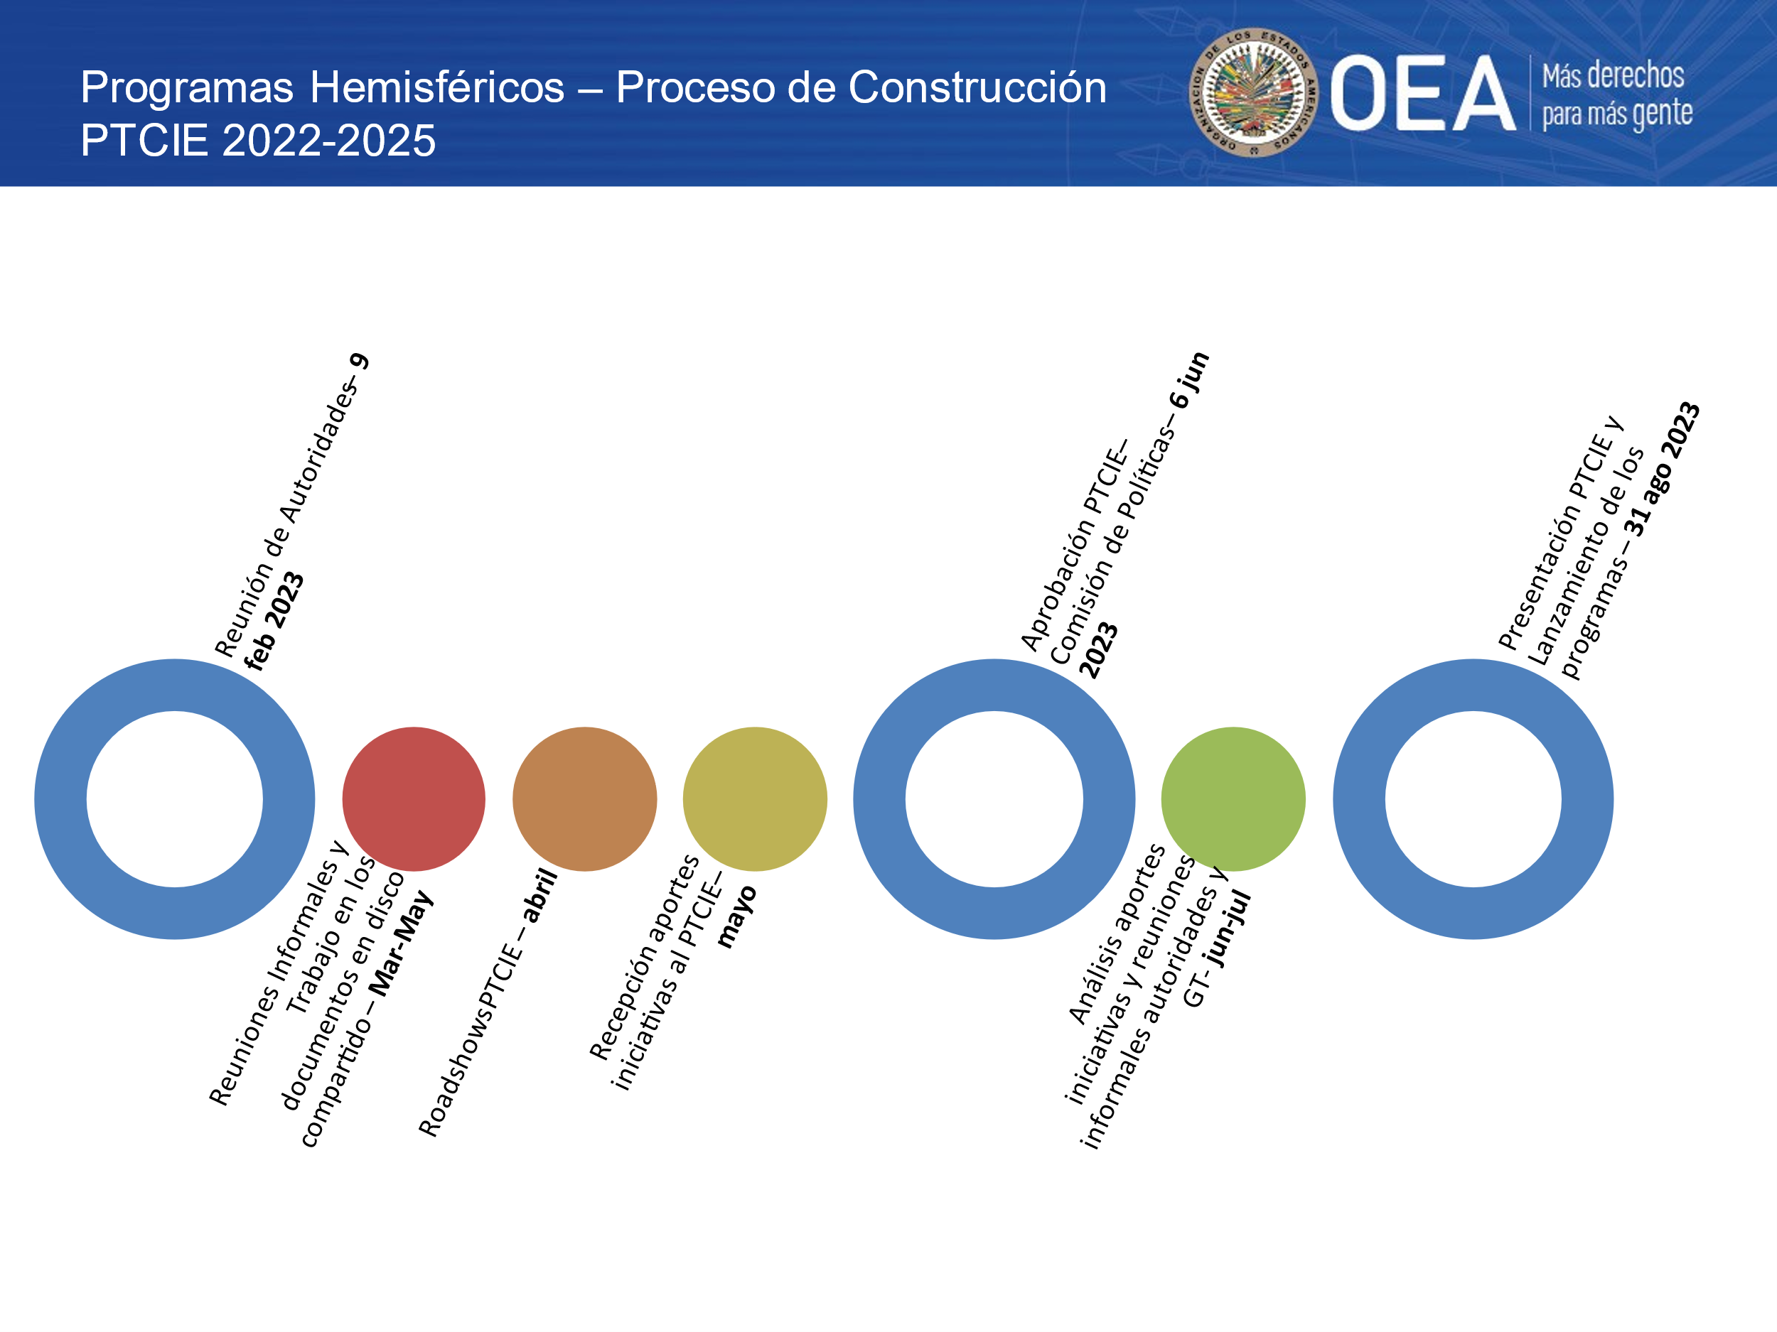

Key to the above: Process of Building Hemispheric Programs PTCIE 2022-2025.

Meeting of Officers Feb 9, 2023. /Informal Meetings and Work on documents in shared drive March – May / PTCIE Roadshows – April / Receipt of inputs on PTCIE initiatives – May / PTCIE Adoption – Policies Committee June 6, 2023 / Analysis of contributions and initiatives and informal meetings of Officers. Working Group June – July / Presentation of PTCIE and launching of programs August 31, 2023.

# ESTABLISHED METHODOLOGY FOR PTCIE IMPLEMENTATION

Joint planning as a mechanism for collaborative work needs to translate into a series of conditions to achieve the proposed objectives: preconditions for joint decision-making; leadership, technical conditions, and administrative capacity.

It should be noted that, under the leadership of the CIE Officers, clear opportunities for dialogue emerged, which were progressively consolidated and strengthened, based on the following structure:

1. **Process for developing the Work Plan:**
2. Ministry of Education authorities request the OAS Technical Secretariat for a first draft of a conceptual framework for the Work Plan.
3. The collaborative process begins with an invitation to officials responsible for relations with the CIE to participate in biweekly work meetings.
4. All Ministries of Education are invited to submit their contributions to the programs defined in the PTCIE through a virtual form.
5. The Technical Secretariat conducts a cross-reference analysis to establish and identify common trends and differentiating elements.
6. Virtual discussion sessions *(road shows*) are held with the Ministries of Education.
7. The final version is submitted for approval.
8. **PTCIE Implementation Methodology**

The PTCIE implementation process entails:

1. **Framing the execution process**: this consists of a virtual dialogue in which the authorities in charge of the process, with the support of the Technical Secretariat, present the PTCIE programs. This phase may include the participation of one or more countries spearheading initiatives related to the various themes.
2. **Forming roundtables (*Task Force*)**: in order to identify lessons learned, challenges faced, and specific elements of the contributions received, it is suggested that the roundtables cover the three components that make up the essence of the Hemispheric Programs: a) research, b) professional development and educational resources, and c) technical assistance and exchange of experiences.
3. **Calling for contributions:** All ministries of education are invited to send their contributions for the components of the Hemispheric Programs defined in the PTCIE through a virtual form. For the 2022-2025 period, more than 300 contributions were received from the Ministries of Education.
4. **Cross-reference analysis:** the Technical Secretariat conducts a cross-reference analysis to establish and identify common trends and differentiating elements.
   * 1. **Professional Development and Educational Resources Component:** An initial review is conducted of the content of the contributions received and the Technical Secretariat prepares a first curricular proposal. Subsequently, several virtual sessions are organized with the working groups to collaboratively define the correlation between the contributions and the thematic axes of the curriculum.
     2. **Research component:** Based on the contributions received, the Technical Secretariat prepares a first proposal for the structure of the white paper. Subsequently, several virtual sessions are organized with the working groups to collaboratively define the correlation between the contributions and research priorities.
     3. **Technical Assistance and Exchange of Experiences Component:** Based on the analysis of the contributions, a series of virtual dialogues are held to exchange experiences on public policies and national programs. The final objective is to systematize the state of the art of a specific topic in the region and, in the parallel sessions of the working groups, to identify possible actions for the exchange of experiences and technical assistance missions.
5. **Virtual event on progress made with the 3 components of the Hemispheric Programs:** The purpose of the meeting is to present the progress achieved in the various sessions of the working groups to all the ministries of education.
6. **Implementation of hemispheric training courses / Draft white paper**: Following the virtual event on progress made, the comments and contributions received are reviewed, the hemispheric training courses are implemented , and the draft white paper to be presented at the Regular Meeting of the CIE is finalized.
7. **Preparation of the draft white paper**: Following the virtual event on progress made, the comments and contributions received are reviewed and the Technical Secretariat proceeds to prepare the draft white paper to be presented at the CIE Regular Meeting.
8. **Presentation of progress made at the CIE Regular Meeting**

# DISTRIBUTION AND CONSIDERATION OF PROPOSED DOCUMENTS PRESENTED DURING THE REGULAR MEETING OF THE CIE

At this stage, the documents presented and approved during the Regular Meeting of the CIE will be distributed. Each Ministry of Education will receive a copy for its consideration.

The ministries of education are expected to actively participate in this stage prior to the Inter-American Meeting of Ministers of Education and, if necessary, contribute with suggestions for improvement, which will be considered when preparing the final documents for the ministerial meeting. This collaborative process ensures that proposals reflect the needs and perspectives of all member countries, thus promoting effective and consensual implementation of the educational policies discussed.

# ANNEXES: TIMELINES

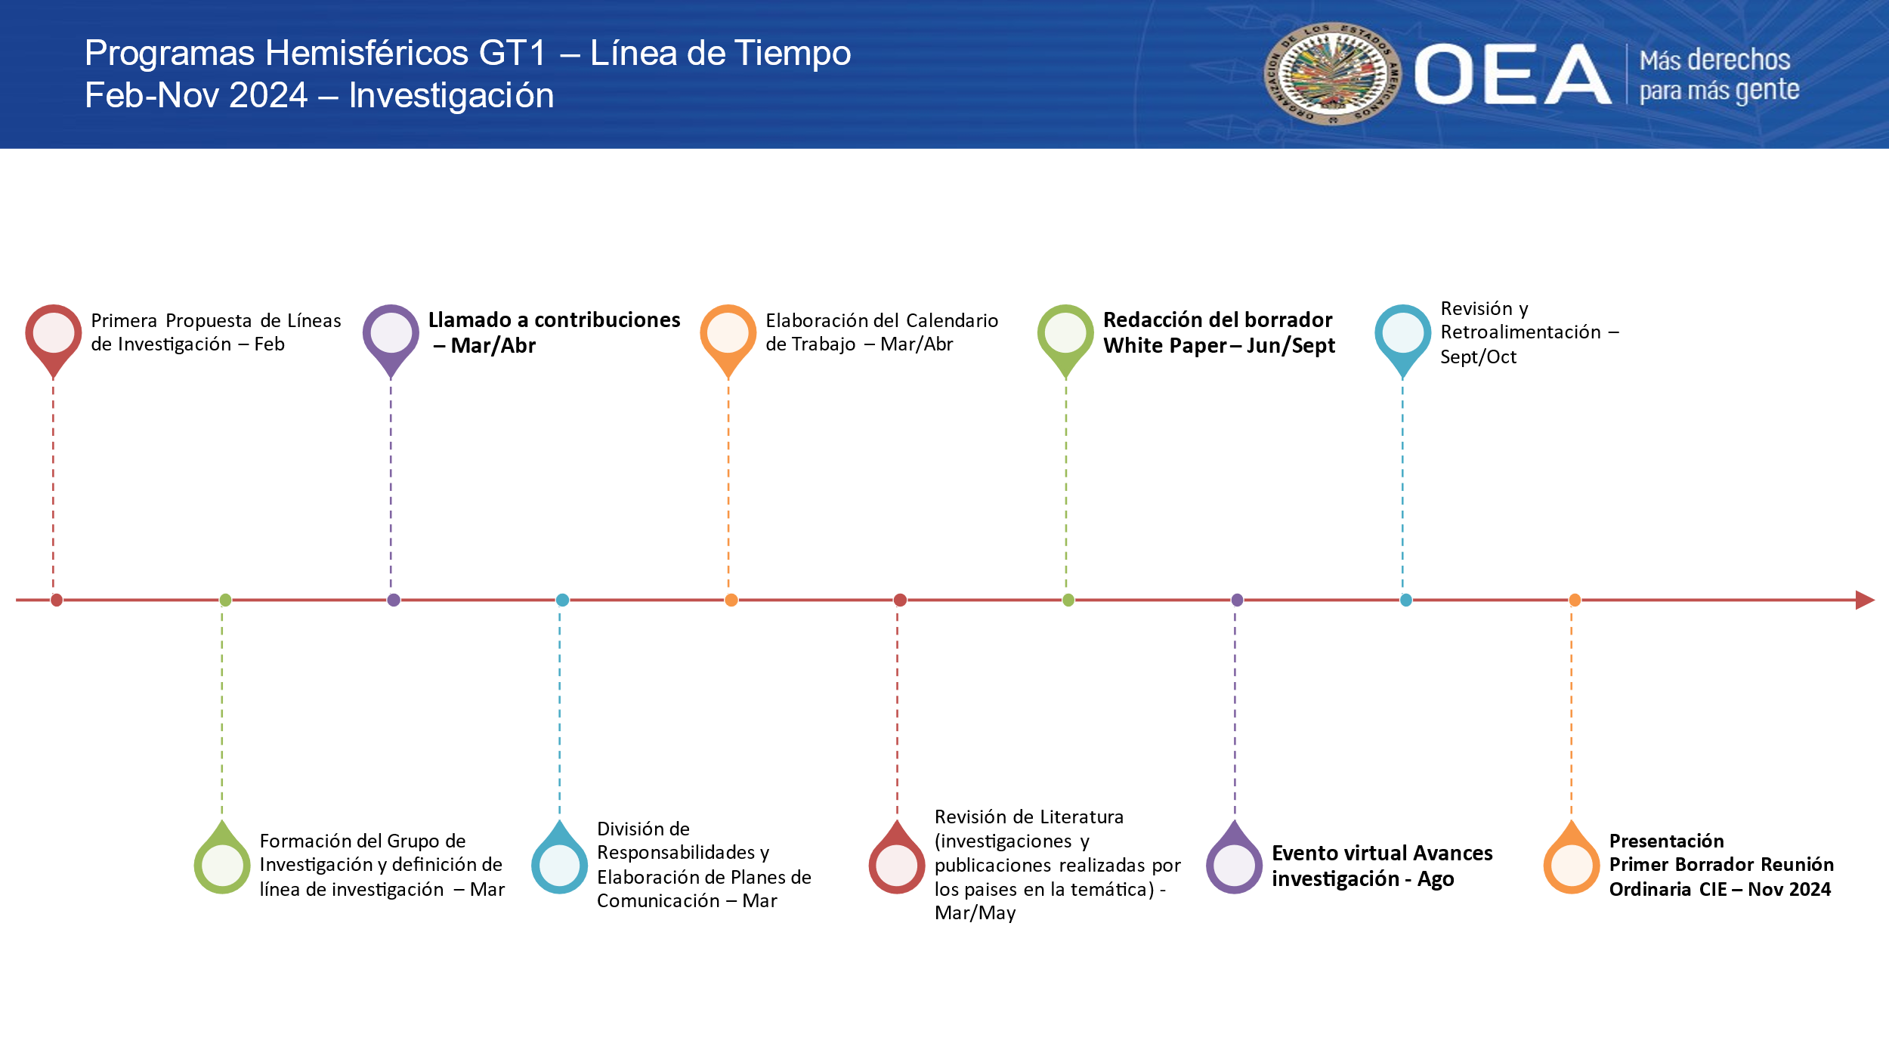

Key to the above:

Hemispheric Programs WG1 – Timeline February – November 2024 – Research

First proposal for Research Areas – February / Establishment of the Research Group and definition of line/area of research – March / Call for contributions – March/April / Division of Responsibilities and Drawing up of Communication Plans – March / Preparation of the work schedule March/April / Review of Literature on research and publications on the subject in the different countries March/May / Drafting of the draft White Paper – June/September / Virtual event on progress made with research – August / Review and Feedback – September/October / Presentation of First Draft at the Regular CIE Meeting – November 2024.

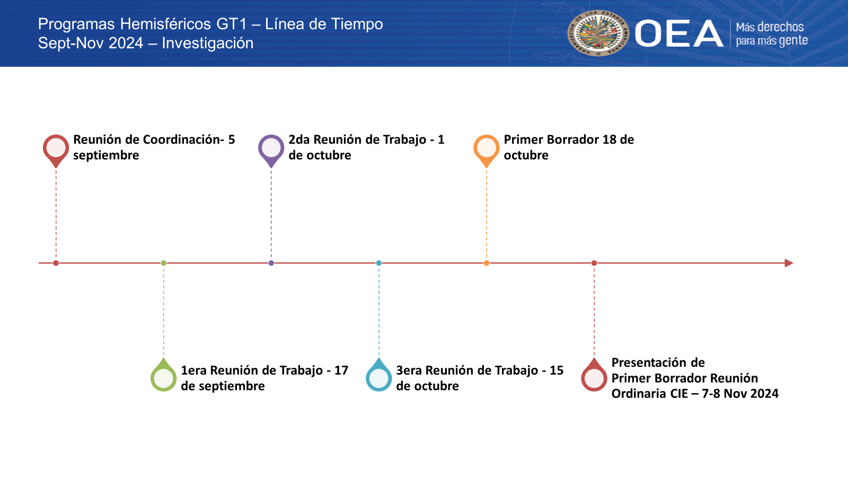

Key to above:

Hemispheric Programs WG1 – Timeline September - November 2024 – Research

Coordination Meeting – September 5 / First Working Meeting – September 17 / Second Working Meeting – October 1 / Third Working Meeting – October / First Draft – October 18 / Presentation of First Draft at CIE Regular Meeting – November 7-8, 2024.

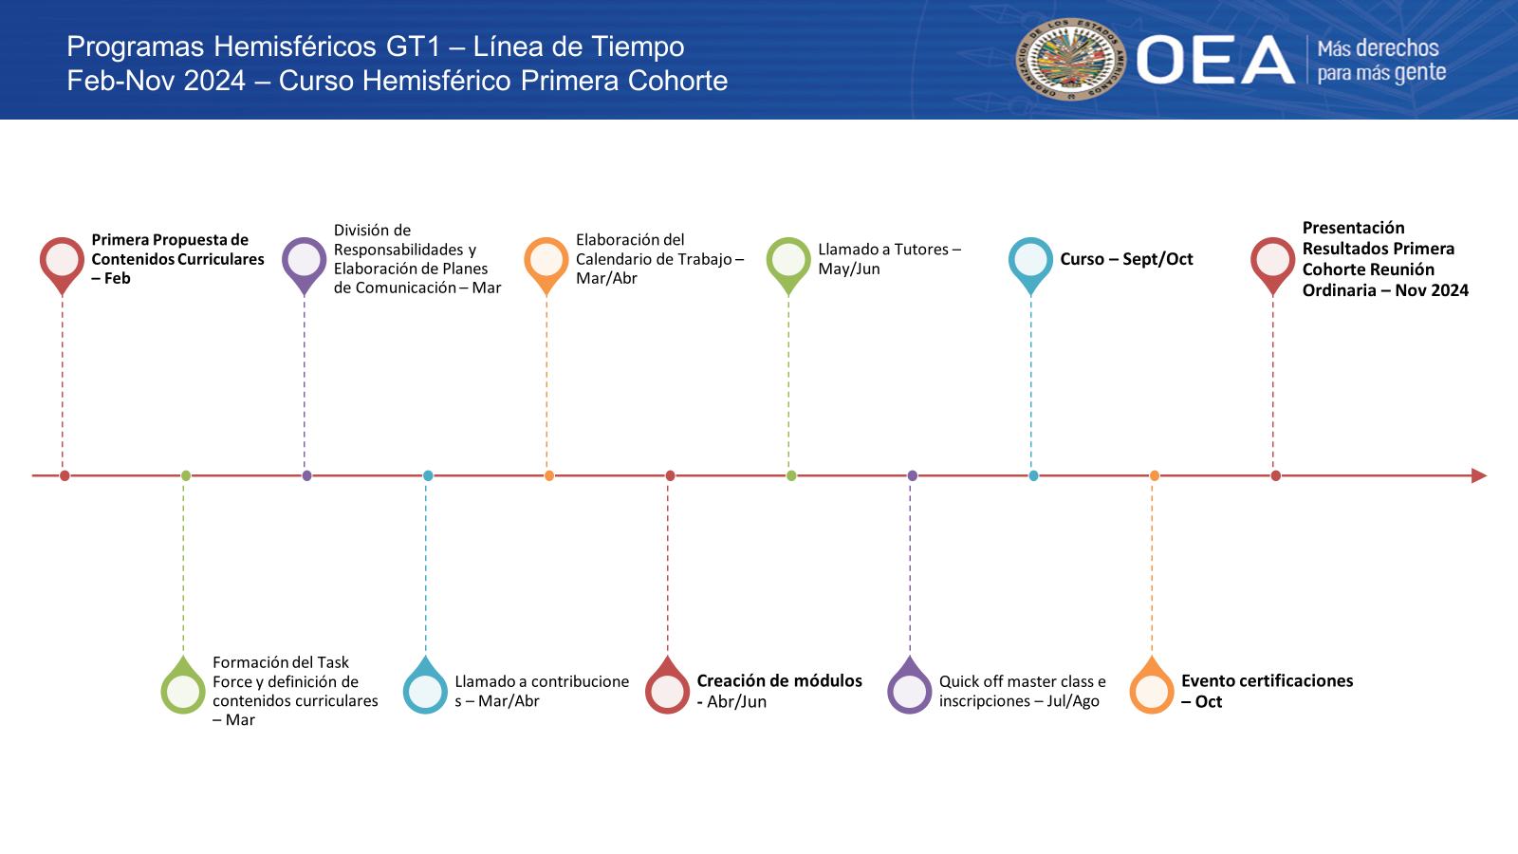

Key to above:

Hemispheric Programs WG1 – Timeline February - November 2024 – Hemispheric Course First Cohort.

First Proposal for Curricular Content – February / Establishment of the Task Force and definition of curricular content – March / Division of Responsibilities and Drawing Up of Communication Plans – March / Call for contributions – March/April / Drawing Up of the Work Schedule – March/April / Creation of Modules – April/June / Call for Tutors – May/Jun / Quick off master class and inscriptions – July/August / Course – September/October / Certifications Event – October / Presentation of Outcomes of the First Cohort Regular Meeting – November 2024.

CIDED00341E04