**TENTH REGULAR MEETING OF THE** OEA/Ser.W/XIII.6.10

**INTER-AMERICAN COMMITTEE ON EDUCATION** CIDI/CIE/doc.9/24

November 7-8, 2024 28 October 2024 Washington, D.C., United States of America Original: Spanish

VIRTUAL

**Progress Report on Compliance with the Work Plan of the**

**Inter-American Committee on Education (WPCIE) 2022-2025**

**Systematization of dialogue**

**Dialogue and Exchange of Experiences on Public Policies and Programs under the Hemispheric Program on Critical Literacy and Digital Education (LICED)**

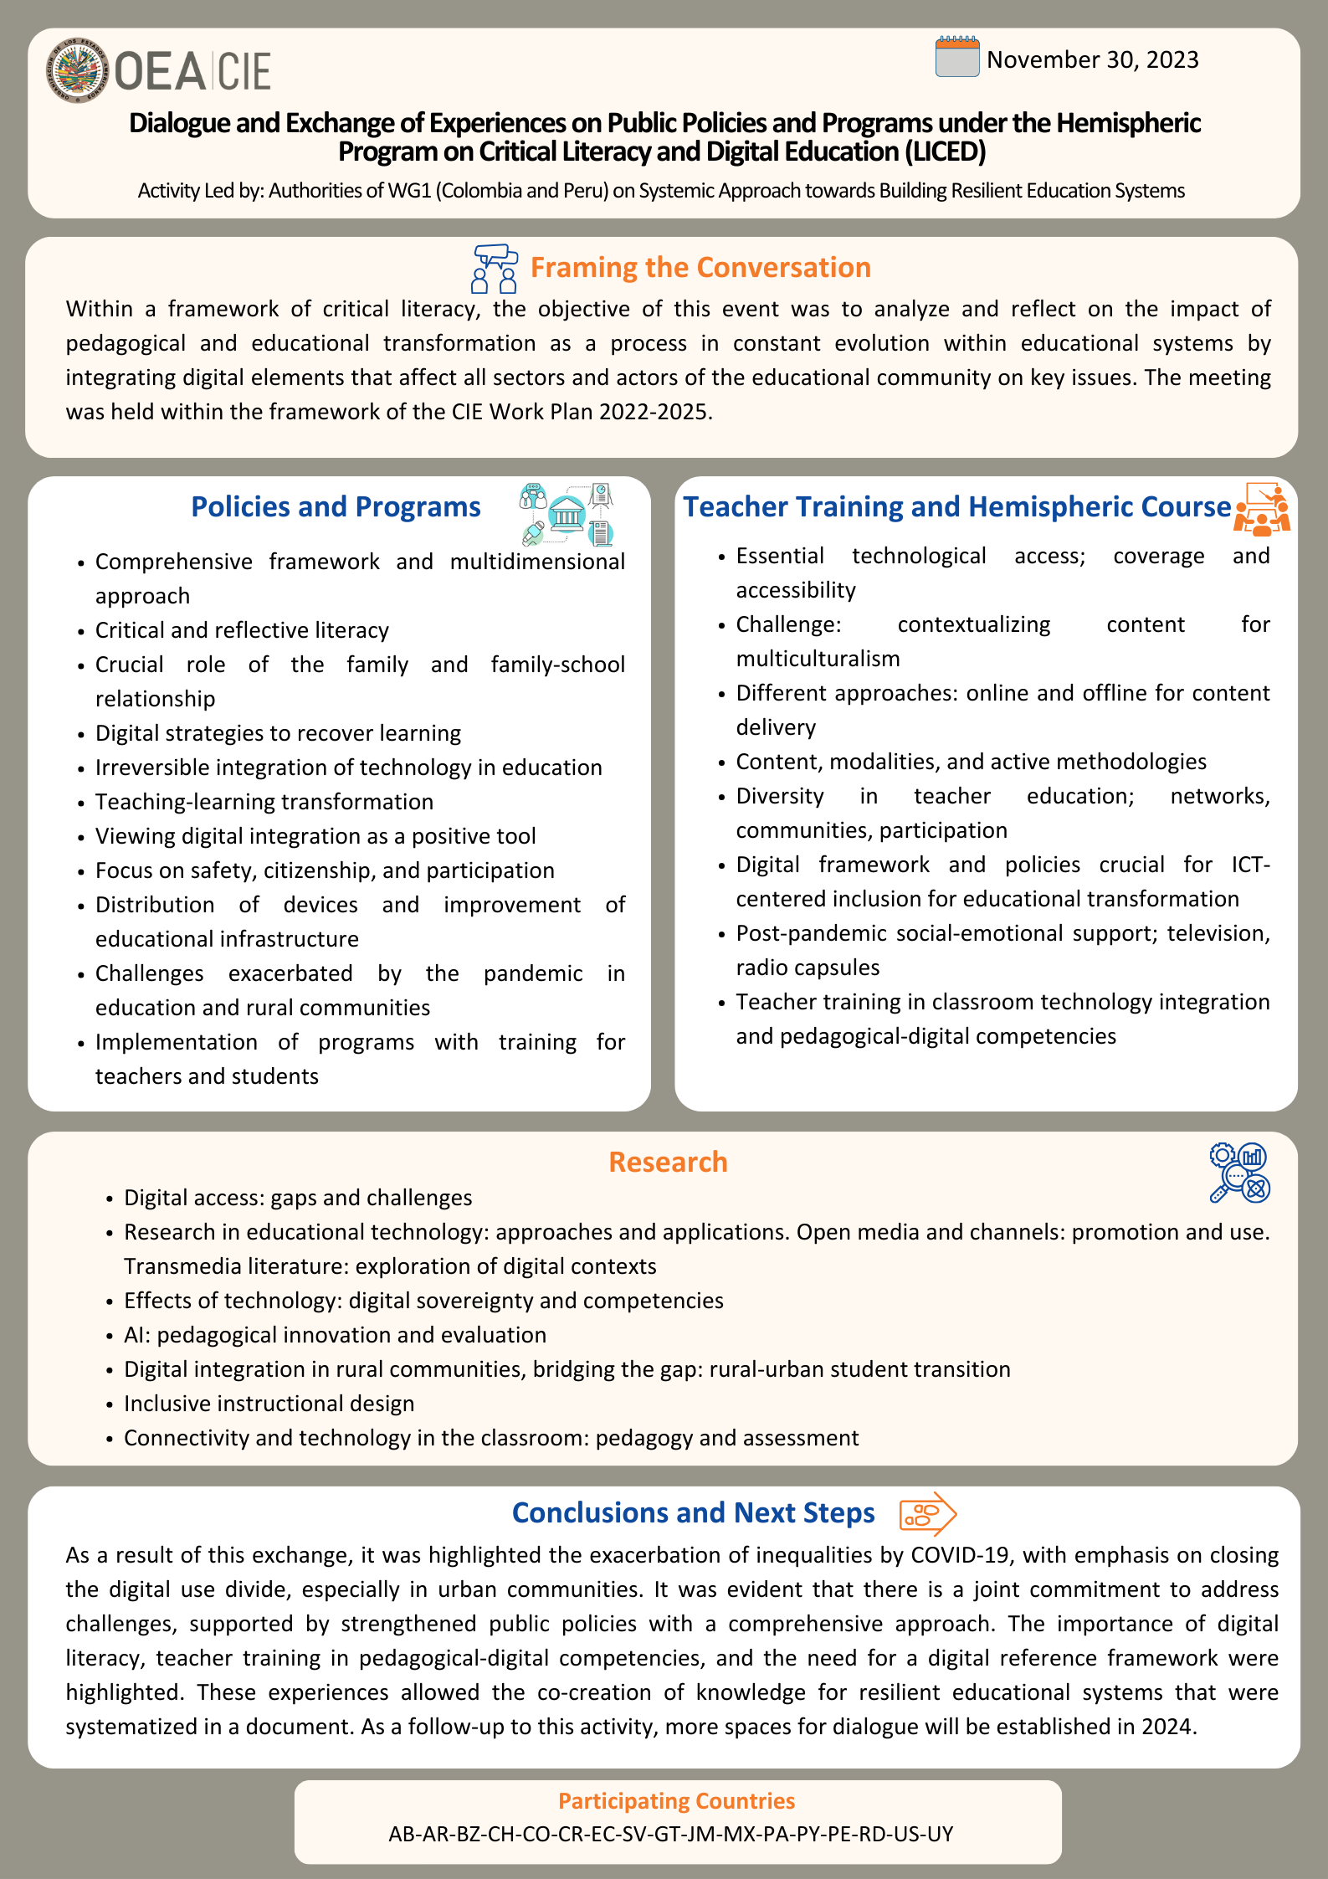

|  |  |
| --- | --- |
| **Event:** Dialogue on Public Policies and Programs and Exchange of Experiences under the Hemispheric Program on Critical Literacy and Digital Education (LICED) | **Date:** November 30, 2023 |
| **Purpose of the Event:**  Within a framework of critical literacy, it seeks to analyze and reflect on the impact of pedagogical and educational transformation as a process in constant evolution within educational systems by integrating digital elements that affect all sectors and actors of the educational community on key issues. | |
| **Participating Countries (17):** Antigua and Barbuda, Argentina, Belize, Chile, Colombia, Costa Rica, Dominican Republic, Ecuador, El Salvador, Guatemala, Jamaica, Mexico, Panama, Paraguay, Peru, United States, Uruguay  **Activity Led by:** Authorities of Working Group 1 (Colombia and Peru) on Systemic Approach for Building Resilient Education Systems | |

The Dialogue and Exchange of Experiences under the framework of the Hemispheric Program on Critical Literacy and Digital Education (LICED), led by the Authorities of Working Group 1 on systemic approach to building resilient education systems, was held on November 30, 2023, and lasted approximately three hours. The event was attended by representatives of the Ministries of Education of 17 participating countries.

Within a framework of critical literacy, the hemispheric program seeks to analyze and reflect on the impact of pedagogical and educational transformation as a process in constant evolution within educational systems by integrating digital elements that affect all sectors and actors of the educational community on key issues. Under the line of Action of Systemic Approach for building resilient educational systems, this dialogue focused on the issue of critical literacy as a framework for reflection for the integration of perspectives that allow defining guidelines for informed and evidence-based decision-making on issues that refer to digital education. To this end, the event focused on reflections on three components: policies and programs, teacher training, and educational resources and research. The activity was divided into five moments.

The activity began with welcoming remarks by Jesús Schucry Giacoman Zapata, Director of the Department of Human Development, Education and Employment (DDHEE) of the Organization of American States (OAS), who offered a brief explanation of the building process of the CIE Work Plan and its four hemispheric programs, their components, and expected results. Each of these programs has a clearly defined path to 2025. He also highlighted that the Program on Critical Literacy and Digital Education has the Regional Guidelines and Hemispheric Protocol on Education in Digital Environments (PH-EED) as its expected result and that this meeting represents the starting point to achieve this result. He concluded his remarks by indicating that a structure with three large areas was proposed in this dialogue, so the session was organized with three working groups, one for each of these pillars.

Next, Ms. Carmen Beltrán, Head of the General Office of Cooperation and International Affairs of the Ministry of Education of Peru as First Vice-Chair of Working Group 1 of the Inter-American Committee on Education (CIE), addressed the paradox of discussing the “digital” in a virtual environment and highlighted the importance of digitalization in education. She explained how digital technologies facilitate access to online resources, tailor learning to individual needs, and foster collaboration in the educational community. She underlined the crucial role of digital education in developing essential skills for a connected world. She highlighted how digital technologies reduce the education gap by providing access to remote communities. She concluded by inviting us to reflect on the transformative impact of digital education, focusing on enhancing learning and critical thinking. She expressed her confidence that, through the exchange of experiences, we will be able to move forward and design public policies that benefit the region's student population.

In a second moment, the topics to be addressed and framed by the planned activities of the Committee were introduced. The third moment was focused on sharing in a panel the experiences and lessons learned from Chile, Ecuador, the United States, and Guatemala regarding the initiatives implemented around the topic. Then, the discussion proceeded in working groups, addressing the pillars of policies and programs, teacher training, educational resources and research. In the fourth moment, a summary of the contributions of the different countries during the working groups was shared in the plenary to conclude the dialogue by establishing the steps to be followed and conclusions.

This document is a compilation of the contributions and exchanges of ideas produced in this virtual meeting. For this document, the knowledge shared at the event is structured in four sections: Framing the conversation, panel, discussion in working groups, conclusions, and next steps. It also includes a summary of the initiatives shared through the digital form sent with the call to Member States. In this case, 16 contributions were received. It should be noted that the countries' contributions are presented alphabetically in all sections.

# **Framing the Conversation**

* Cecilia Martins, Education Specialist, Organization of American States (OAS)

**Highlights include**: Critical inclusive education, Multidimensional approach, Consistency of discourse and action, Comprehensive framework beyond technology, Concept "TRICS": relational factor in ICT, Reflection on initiatives: teams vs. true priorities.

The importance of not losing sight of inclusive education when discussing critical literacy and digital education within a framework that considers education as a right was highlighted. The challenges during the pandemic were addressed, emphasizing urgencies and exclusions, which led to a rethinking of educational policies. A multidimensional approach was presented that considers aspects such as education, technology, management, multimedia, participation, ubiquity, locality, transparency, and inclusivity. The importance of seeking transformation and considering the contexts of change to ensure efficient and people-driven education systems was highlighted.

Digital accessibility was discussed, stressing the need to bridge the technological and contextual gaps. Five essential components for accessibility were mentioned, including contexts of change, accessible educational resources, teacher training, technological and pedagogical frameworks, and integration of perspectives.

Regarding the focus of action, the "four C's" were introduced as guiding principles: consistency, commitment, coexistence, and collaboration. The need to coexist with different implementations and urgencies in education systems was emphasized, underlining the importance of horizontal and open collaboration between countries. Consistency in discourse and action was underlined, based on four "C's" that imply commitment, coexistence, collaboration, and coexistence. The concept of "TRICS" which integrates the **Relational** factor in information and communication technologies (ICT), was explored.

The integration of technologies, the good use of the Internet, and teacher training were explored as priorities identified by the Ministries of Education. However, it was noted that most initiatives focus on providing equipment and infrastructure, urging reflection on priorities beyond equipment. The presentation concluded with a provocative image to reflect on where we focus while integrating technologies and a phrase highlighting the importance of recognizing, accepting, and celebrating our differences.

In summary, the presentation provided a comprehensive framework that goes beyond technology, addressing the complexity of inclusive and resilient education in the region, seeking to enrich the discussion in the working groups, aligning with the Inter-American Education Agenda, and strengthening education systems through systemic approaches.

# **Panel**

* Chile: "Digital Citizenship for Educational Communities" - Katherine Rojas, Professional at the Innovation Center of the Ministry of Education of Chile

**Highlights include:** Ministerial collaboration, new updated framework, international approach to rights and equity, recognition of infrastructure and skills gaps, critical and reflective literacy, comprehensive digital citizenship portal, crucial role of the family, active participation in the digital society, technologies and democratic participation, expression of ideas and collaborative resolution.

Chile presented the experience of the digital citizenship framework for the challenges of educational communities, which was developed at the beginning of 2023. It was stressed that this framework resulted from a collaborative effort between several units of the Ministry, addressing various challenges in Chilean and global education. Challenges such as teacher training in technological aspects, the integration of technology in the teaching and learning process, and challenges related to digital school coexistence were mentioned.

It then was contextualized the evolution of the Ministry's initiatives in this area, from the launch of **the ICT skills matrix in 2013, through the "Safe Internet" plan in 2016**, to the **incorporation of the concept of digital citizenship in 2017 and the national plan for digital languages in 2019. In 2023, they identified new challenges and developed an updated digital citizenship framework.** This approach sought to promote the creative, participatory, safe, responsible, critical, and thoughtful use of digital technologies, recognizing people's digital rights, and understanding their impact at the personal, local, and global levels.

This framework was based on international guidelines, adopting a rights-based approach. The digital infrastructure and skills gap is recognized, working to overcome it and ensure equitable access. In addition, the importance of awareness of biases and gaps is highlighted, encouraging the full participation of all students.

**The digital citizenship framework is built on four dimensions**: critical and reflective digital literacy, digital care and responsibilities, digital citizen participation, and digital creativity and innovation. Each dimension seeks to holistically guide technology use, from technical skills to active participation in the digital society.

Critical and reflective digital literacy goes beyond technical skills, including understanding how technologies work and awareness of biases. Digital care and responsibilities address the safe and responsible use of technology, considering digital coexistence and cybersecurity.

**Digital citizen participation focuses on how technologies enable democratic participation and the ability of users to generate critical spaces for participation and action. The digital creativity and innovation dimension seeks to take advantage of the opportunities of technologies to express ideas, creativity, and collaborative problem-solving.**

Finally, the launch of a new digital citizenship portal from the Chilean Ministry of Education, designed for teachers, students, and families, was announced. This comprehensive approach recognizes the family as a fundamental part of the educational community and highlights the importance of their role in accompanying children and adolescents in their digital experience. Participants were invited to explore the portal, which offers resources and support to address the challenges of the digital citizenship framework. The commitment to equity, civic awareness, and innovation stands out in this new framework, reflecting the vision of an inclusive digital educational future.

* Ecuador: Educating in the Family Program - Module **"Promotion of rights in the safe use of the Internet from families"** - Jennifer Barrera, Analyst of the National Directorate of Education for Democracy and Good Living

**Highlights include:** Co-responsible participation, Reflective workshop with families, Experiential community meeting, Cascade training, Alliances with local actors, Protocol against digital violence, Family-school relationship, Digital coexistence skills.

In the presentation made by Ecuador, the implementation of the "Educating in the Family" program was highlighted, focusing especially on the module for promoting rights in the safe use of the Internet by families. **This program aims to provide tools to families to promote their co-responsible participation in the educational process of their sons and daughters, strengthening their capacities over time**.

Unlike traditional schools for parents, the program's approach recognizes the existing capacities of families to educate their children and strengthen them by providing tools, resources, and spaces for reflection and dialogue from educational institutions.

The initiative was developed after a diagnosis that identified various needs of families, including education in values, sex education, prevention of psychosocial risks, drugs, and bullying. With the arrival of the COVID-19 pandemic, the need to accompany families in virtual and digital environments was incorporated. The main objective of the module on the promotion of rights in the safe use of the Internet is to promote the rights of children and adolescents in the safe use of the Internet, involving families, teachers, and caregivers in guaranteeing and protecting these rights.

**The methodology of the program consists of three cyclical moments**. In **the** **campaign,** the educational institution activates the socialization of the issue through a slogan, generating discussions and reflections in the classrooms with the participation of students and teachers and resources of communication material for families. The second moment is the **workshop with** families, where space for reflection and dialogue is sought, good practices are shared, and a micro-curriculum designed to facilitate communication between teachers and families is used. The third moment is **the community meeting**, which makes visible what was worked on in the campaign and the workshop. It includes exchange days, cultural activities, games, and strengthening family and school relationships.

The module addresses topics such as online and offline rights, the safe use of ICTs, skills to live in digital environments, and identifying and preventing risks such as sexting and cyberbullying. The importance of strengthening the family-school relationship is highlighted. The cascade training methodology allows each school district to be reached. In addition, the importance of alliances with local actors was highlighted, and a protocol for action against situations of digital violence detected in the national education system was shared.

In summary, Ecuador has implemented a comprehensive program involving families in promoting rights to safe Internet use, addressing relevant issues, and strengthening the relationship between the educational community and local institutions.

* United States: **"Artificial Intelligence and the Future of Teaching and Learning**" - Sara Trettin Senior Policy Advisor, Office of Educational Technology, U.S. Department of Education

**Highlights include:** Transforming Teaching and Learning, Intersection AI and Education, Guide for Educators, Mitigating Risks, Recognizing the Scope of AI, Balancing Teacher Control, Informing and Engaging Educators, AI Tools for Educational Leaders, Addressing Learning Variability, Focus on Teachers, Students, Systems Integration.

The presentation on the National Educational Technology Policy developed by the U.S. Department of Education's Office of Educational Technology aims **to shape the vision for using technology in transforming teaching and learning at all levels of education. The department's focus on key issues such as digital equity, accessibility, and teacher training was highlighted.**

The main theme of the presentation revolved around the intersection of Artificial Intelligence (AI) and education. It was emphasized the relevance of this work in the context of the ongoing digital transformation in education systems. **A policy brief that addresses the need to share knowledge, engage educators, and refine technology plans and policies related to artificial intelligence in education was presented.**

The report, developed over a year with input from various sources, aimed to guide educators to understand the potential of artificial intelligence in advancing educational goals while assessing and mitigating the associated risks. The report was not intended to be the final word but rather a starting point for a crucial conversation about the growing presence of artificial intelligence in education.

The definition of artificial intelligence, highlighting two significant changes from previous educational technologies, was addressed. First, artificial intelligence collects and organizes data and infers patterns. Second, it provides access to learning resources and makes decisions about the presentation of these resources. The importance of recognizing the broader scope of AI applications and preparing for their full potential was emphasized.

**Insights from the report included how artificial intelligence can address variability in student learning and support more powerful forms of adaptability**. The analogy of imagining artificial intelligence in education as an electric bicycle, enhancing human efforts rather than replacing them entirely, was shared. It was acknowledged that there are tensions around the role of artificial intelligence in education, especially the balance between teacher control and technological autonomy. Key questions focused on how the system focuses on teachers and students, how humans are kept in the process, and how AI systems integrate with the existing education system.

Several recommendations were highlighted, emphasizing keeping humans in the process, informing, and engaging educators, and focusing on research and development to address contextual considerations. Ongoing efforts, including developing an AI toolkit for education leaders, a guide for developers, and educator roundtables to gather insights were outlined.

The presentation concluded with mentioning the **upcoming National Educational Technology Plan, which is scheduled for launch in January 2024.** This plan, a flagship document for America, aims to provide a roadmap and vision for state and local school districts. The updated version will incorporate examples from all 50 states, Washington, D.C., two territories, and examples from the juvenile justice system.

* Guatemala: "**Technology in the Classroom" Access to Resources without Internet and Prioritized Curricular Areas** - M. Sc. Claudia Ruíz Casasola de Estrada, Minister of Education

**Highlights include:** technological kits, teacher certifications, virtual communities, intercultural bilingual education, virtual environments prevent irregular migration, municipal support, remote and face-to-face tutoring, flexible education, content on the environment and risk management.

The Minister of Education of Guatemala shared the experiences with the technology in the classroom program initiated in 2022, which **seeks to facilitate the use of technological tools for curriculum development, build teaching-learning paths, and apply assessments in the classroom**.

The technology kit includes tablets, video, a projector, and a content dispatch server with curricular resources in several national languages. She highlighted the versatility of turning a conventional wall or whiteboard into an interactive whiteboard, even in rural areas without electricity access, where solar panels have been installed. The program involves 24 hours of training for teachers to obtain digital competency certification.

The integration of technological tools in teaching, assessment, and learning through digital devices and resources was addressed. Teachers learn to plan and design teaching tools, building learning paths. The certification of teachers and the participation of educational centers, including those in remote communities with difficult access, addressed by solar panels, are highlighted.

Certified teachers can share experiences and content in a virtual community. Attention to intercultural bilingual education in rural areas is highlighted. Teacher certification includes assessment, technology training, and content development. The platform contains materials from the Ministry of Education and topics such as environment and risk management.

The content dispatch server facilitates dynamic classes with or without connectivity, creating a community of teaching practice. Statistical monitoring allows students to evaluate attendance and performance. The increase in motivation and interactivity in class is highlighted. Virtual learning environments prevent irregular migration in remote communities by offering flexible education. Certified digital municipalities receive support from national and international cooperation.

The program is integrated into the education cluster, activated during the pandemic. In summary, inclusion, teacher training, and promoting digital learning throughout the country through this program were highlighted.

# **Discussions in Working Groups**

Summary of the highlights of each working group

|  |
| --- |
| **Policies and Programs** |
| * Articulation of strategies related to the "3Rs" and using digital resources and technological devices for learning recovery. * Debate on countries' position regarding critical literacy and its relationship with “the digital” to achieve objectives. * Exchange of experiences on national plans to strengthen education for children and young people, highlighting the role of educational platforms. * Recognition that we are at a point of no return in incorporating technology in education. * Emphasis on the need to see technology and digital as positive tools to move forward. * Mention the interest in delving into hemispheric guidelines and protocols related to technological security. * Focus on bridging the digital divide with public-private partnerships. * Distribute devices (laptops for teachers, tablets for students) and improve infrastructure. * Pre-existing challenges exacerbated by the pandemic. * Emphasis on the challenge with rural communities and collaboration with telecommunications companies. * Implementing programs for elementary and secondary schools, including training for teachers and students. * Challenges for some teachers adapting to digital education strategies due to the pandemic. |
| **Teacher Training and Hemispheric Course** |
| * Importance of access to technology in terms of coverage and accessibility. * Content generation, highlighting the challenge of contextualizing in cases of multiculturalism. * Different approaches to online and offline content delivery. * Consensus that providing devices is insufficient for effective classes; Emphasis on teacher training. * Need for digital literacy, security, content generation, synchronous and asynchronous modalities, and active methodologies to take advantage of technology. * Diversity in how countries approached teacher education, using learning networks, virtual communities, and parent involvement. * **Highlight the importance of a digital reference framework and policies for digital inclusion and virtual education**. * Mention of post-pandemic socio-emotional support programs, such as television and radio capsules. * Recognition of the importance of emotional support and its inclusion in the regional course. * Local training for teachers in the use of ICT in education. * Emphasis on decentralization and support through non-governmental organizations. * Focus on teacher training on integrating technology into the classroom. * Development of ICT-focused education policy to support a knowledge-based society and transform education. |
| **Research** |
| * Two main lines of research: To have or not to have access and what it entails. * Gaps are generated in both situations. * Four sub-lines of research - How and what to have: * Media: focus on free software and multi-stakeholder construction for digital sovereignty. * Channels: use and promotion of open, multi-device, and multi-tier formats. * Transmedia literature: exploring contexts for the use of digital themes. * Effects: consideration of digital sovereignty, teaching competencies, individual needs, and articulations. * Cross-cutting theme: using and promoting artificial intelligence as an innovation, pedagogical strategy, and evaluation. * Digital Integration in Rural Communities. * Inclusive instructional design. * Bridging the digital divide with a focus on transitioning students from rural to urban communities. * Emphasis on ensuring connectivity and researching the best technology integration in the classroom in pedagogy and assessment. * Addressing various digital divides, including physical accessibility for rural communities and specific learning needs. * Identified challenges: The gap between rural and urban communities requires specific research, especially when moving students. |

Summary of initiatives through the form

|  |
| --- |
| Countries: Argentina, Belize, Colombia, Dominican Republic, Ecuador, Jamaica, Panama, Peru, Saint Vincent and the Grenadines, United States |

Topics addressed in the initiatives:

Associated Components:

Contributions by country:

* **Argentina:** The digital divide was bridged in Argentina by implementing a program that distributed notebooks in all schools, connecting them to a free and open-source system. This initiative not only guaranteed the effective return of students but also introduced a platform with open and interactive mathematics and language content, offering innovative proposals. The digital design adopted facilitated dialogue and learning, while virtual environments provided new educational opportunities. In addition, the pedagogical policy framework at the national level was reconstructed, emphasizing a constructivist approach. Challenges identified in Argentina included the need to articulate policies, generate a shared agenda, promote a political perspective based on inclusive work, and effectively support management teams.

They highlighted the "**Connect Equality**" program, which provided more material access and focused on developing platforms and software, offering content in various formats. More than 250 open-source applications were implemented, promoting pedagogical sovereignty. The Moodle platform was used to create a virtual classroom and a digital library offering exportable content. Situated teacher training and a focus on multiple literacies were priorities to ensure the effectiveness of digital education. It focused its efforts on the distribution of computers. **However, significant concern arose about the limited space that free and open software and content were occupying in development. Despite talk of equality and accessibility, the reliance on proprietary software raised concerns about data privacy. Argentina highlighted its commitment to digital, technological, and pedagogical sovereignty through free software and open content**.

* **Belize:** In Belize, the digital divide was evident. Focusing on rural communities, the government partnered with local telecommunications companies to implement a program called **ConnectEd** in primary and secondary schools, providing training to teachers and students on digital tools. Through the **Teacher Learning Institute, teachers were provided training on how to use ICT in the classroom**. It was proposed to investigate inclusive instructional design, addressing the digital divide with a special focus on students' transition from rural to urban communities. In addition, through the form, they shared the Rotary International Literacy Alive Reading Intervention Program aimed at students in levels 2 (third grade) and 3 (fourth grade) who have reading difficulties. Teachers have been trained to assess students' language proficiency levels, analyze data, and form intervention groups. Teachers have also received electronic resources to support them through the Belize Teacher Learning Institute.
* **Chile: A challenge related to teacher training was identified, as well as the need to establish a line of training** and the systematization of the work carried out. The importance of addressing digital inclusion from a gender perspective was underlined, recognizing that the use of technology and the development of digital skills are unequal between men and women. In addition, **the need to influence digital citizenship policies and promote media literacy to critically analyze the information received from various media was pointed out.**
* **Colombia:** Productivity strategies that guaranteed the necessary resources for connectivity were implemented. Technological equipment and data packages were distributed, and teacher training processes and curricular restructuring were carried out. With the support of other ministries, content was generated for the development of pedagogical processes and placed on the Ministry of Education's website. They highlighted his "**National Plan for Reading, Writing and Orality**", promoting libraries and strengthening reading and orality throughout the educational community. Knowledge management and the narration of territories through radio programs such as "Historias en Alta Voz" were effective strategies. The policy focused on critical literacy and 21st-century skill development, embracing text comprehension and cyber hygiene as crucial elements.

**The issue of accessibility and technology was addressed, recognizing significant challenges in rural areas**. A crucial question was raised about possible strategies to serve populations in remote areas. The risks associated with access to networks, especially in rural areas, stood out as a particular challenge. The need for excellent technological proficiency became a challenge, especially in rural contexts. A focus on digital tools and digital security was observed through publications and curriculum guidance. The need to consider the appropriate use of technology in school and digital environments was highlighted. The harmonization of these publications was highlighted, and **the importance of the National Reading and Writing Program was noted for its alignment with critical literacy. Colombia highlighted the need to focus on students and teachers, emphasizing teacher education as a key component.**

* **Costa Rica:** Focused on teacher training, establishing a **hemispheric framework of digital inclusion policy.** A differentiation was made in the methodology to educate from the virtual and digital platforms.
* **El Salvador:** During the pandemic, policies were implemented at the national level to transform education towards digital environments. Under the "Google Word Face" initiative and as part of state policy, it was guaranteed that all students had access to Google Word Face. In addition**, a training plan was designed for teachers, recognizing that they are not digital natives, unlike students. Technological supplies were delivered to 100% of the student population**, with tablets from early childhood and laptops in high school becoming the student's property. Curricular linkage was a crucial aspect of this process.

**Books distributed to all students included digital inputs, such as short links, QR codes, simulations, and controlled content**. In addition, augmented reality was introduced in the science and technology book. Language strategies included the creation of a digital library for access from technological devices promoting living books.

* **United States:** The pandemic highlighted the gap in internet access in households. As a result, the government provided **emergency funding through affordable connectivity programs to allow more families to afford internet access at home**. In addition, programs were established in collaboration with other agencies to provide free access to meals for students and toolkits for teachers and school leaders. In relation to teacher **training, the International Society for Technology in Education provided local training for teachers on the use of ICT in education, as well as assistance with access to educational technology. The Center for Accessible Educational Materials offers a variety of training resources. The Department of Education's Office of Special Education funds the Center on Inclusive Technology & Education Systems (CITES).**
* **Jamaica:** To bridge the digital divide, the government was able to establish public/private partnerships to distribute laptops to students and establish relationships with telecommunications companies to provide internet services to students, especially those in rural communities. **Teacher training was conducted to integrate technology in the classroom, and ICT in education policy was developed to support a knowledge-based society and assist in transforming education in Jamaica. They set out to investigate digital integration in rural communities.**
* **Guatemala:** Solar panels were implemented to facilitate connection, facing challenges of lack of connectivity and access to content, especially in virtual communities.
* **Mexico:** They changed its educational model during the pandemic, **rethinking the concept of critical literacy in depth.** Digital inclusion was considered from a gender perspective, recognizing inequities between men and women in developing digital skills. **The importance of media literacy to critically analyze information from all media was emphasized. In general, the need to influence digital citizenship policies by introducing** **new technologies was recognized.**
* **Panama:** Printed teaching guides were developed and available in digital format. Radio programs were implemented for students, and agreements were signed to develop applications. They presented their "**Smart Educational Transformation" (ESTER) initiative, an ecosystem that included teachers, students, families, and the administrative team. The electronic notebook was a central tool in this transformation, although Law 294 has not yet made it a norm. This approach demonstrated an evolution towards a broader, more collaborative educational ecosystem.**
* **Paraguay:** Adopted short television programs for different grades, platforms with educational content, and the publication of materials in newspapers. The support among teachers to continue their work was highlighted. It addressed the difficulties related to access gaps, especially during the pandemic. **The importance of developing pedagogical approaches that take advantage of digital tools was highlighted. Sustainability and continued access to technologies for teachers and students were critical elements. The search for comprehensive and pedagogical approaches that use** **new technologies for the development of critical thinking and critical literacy was highlighted as a priority.**
* **Peru:** In Peru, a comprehensive plan was designed to close the digital divide, focusing on the development of teachers' professional skills and student learning. At the teacher level, the “Program to strengthen competencies for teachers using portable electronic devices” was implemented, benefiting 49,850 teachers in 26 regions of Peru. This program sought to have an impact on the development of the teaching and learning process through the pedagogical use of technological resources, strengthening the skills of both teachers and students. **The implementation was conducted in hybrid mode, facing challenges such as the lack of connectivity in rural areas, as well as linguistic and intercultural diversity. There was interest in conducting research on the integration of technologies for teacher development.** The focus was on understanding how digital competencies are developed in in-service teacher training. Likewise, through the Monitoring Unit of the Ministry of Education, school practices monitoring was implemented, which focuses on the collection of information in the national territory in order to generate evidence to understand and make decisions on the dimensions of teaching-learning, climate and school management that occur within the public educational services of pre-school, primary and secondary schools.
* **Dominican Republic:** A program was developed focusing on the pedagogical approach**. Connectivity points were created to facilitate student access, recorded classes were prepared for broadcasting, and a supportive policy was established to acquire equipment and digital literacy for students, teachers, and the parent community. Digital content was also created, including an open book with digital versions for general access.** Challenges in the Dominican Republic were linked to a lack of connectivity, similar to the situation in Colombia.

**A comprehensive critical literacy strategy was adopted, seizing the opportunity of technology during the pandemic**. Teachers were provided with interactive screens, and a program based on the use of technology was implemented. Tablets were provided at the primary level, ensuring proper use aligned with pedagogical strategies. The introduction of an open book and virtual links in 2023 demonstrated the commitment to timely digital literacy. In the same way, through the form, they shared the experience of the **implementation of the CON BASE program, which supports its implementation in Didactic Guides with specially developed sequences and its corresponding theoretical guides to have the conceptual foundations, enabling the subsequent transfer to other contents, areas, and grades.**

# **Conclusions and next steps**

As a result of the Dialogue and Exchange of Experiences under the framework of the Hemispheric Program on Critical Literacy and Digital Education (LICED), a fruitful exchange of policies, programs, teacher training, and possible lines of research was achieved. Among the topics discussed, it was possible to corroborate that the context of COVID-19 intensified existing inequalities, and initiatives to reduce the digital divide and ensure the continuity of education were highlighted. It revealed a deep collective reflection on the intersection between policies and programs, teacher training, and education research. The convergence of strategies related to the "3Rs" and the use of digital resources was highlighted, pointing to a consensus on the irreversibility of technological integration in education. Countries shared national plans to strengthen education, emphasizing the need to see technology as a positive tool.

The importance of digital literacy and the need for a digital frame of reference were underlined in teacher training. Decentralization and support through non-governmental organizations were recognized as critical to effectively training teachers in integrating technology into the classroom.

The research identified key lines focused on access and digital content. The gap between rural and urban communities emerged as a challenge requiring specific research. Outstanding contributions, from technology kits to remote mentoring, highlighted concrete initiatives to transform teaching and learning. There was evidence of a joint commitment to address challenges, with a comprehensive focus on technology as a catalyst for educational transformation, supported by concrete programs, effective teacher training, and proactive research.

As part of the ministerial process, the CIE Technical Secretariat has supported member countries in systematizing the strategies, actions, and programs implemented to guarantee educational continuity in contexts of change. This document synthesizes the steps discussed to strengthen the region's public policies.

Likewise, the value of this type of exchange was recognized so that, with the leadership of Working Group 1 and the support of the Technical Secretariat of the CIE, other spaces for dialogue will be established during 2024 to continue the conversation and exchange of documentation.

# **Participants**

|  |  |
| --- | --- |
| **Country** | **Name** |
| **Antigua and Barbuda** | Shelly Galloway |
| **Argentina** | Ignacio Balard  María Eugenia Castiñeiras  Sergio Fernandez  Mateo Parada  Laura Penacca  Javier Castrillo  Valeria Aranda |
| **Belize** | Marion Nolberto |
| **Chile** | Katherine Rojas  Amparo Navarrete |
| **Colombia** | Andrea Vera  Alicia Vargas  Diana Garavito  Nestor Suarez  Pilar Londoño  Luz Andrea Rojas  Diana Belén Mora |
| **Costa Rica** | Juan Ricardo Wong Ruiz  Jorge Tortos |
| **Ecuador** | Jennifer Barrera  Samantha Gilbert  Fernando Naranjo  Sebastian Fonseca |
| **El Salvador** | Jorge Avila  Ernestina Reyes |
| **United States** | Sara Trettin  Rafael Nevárez  Christina Heifferon |
| **Guatemala** | M. Sc. Claudia Ruíz Casasola de Estrada  Annelisse Lainfiesta Soto de Zepeda  Carlos Bautista  Luis Zapeta  Iris Gámez |
| **Jamaica** | Timar Stephenson |
| **Mexico** | Cesar Garces  Socorro Jorge |
| **Panama** | Jesús Chacón  Anabella Yepes  Juan Zeballos  Cyrus Esclopis  Elio Abner Aparicio  Marisol Batista  Brizuela Cristina |
| **Paraguay** | Edgar Brizuela  Ariel Bado  Rodrigo Britez |
| **Peru** | Carmen Beltrán  Fabrizio Gonzalo Ruiz Rufino  Hugo Florez  Lena Morales  Cristina BG  Kelva Morales  Tomás Osores  Arturo Kam  Elisa Diaz |
| **Dominican Republic** | Juleidy Dilone  Cilia Quezada  Bianny Matos  Norma Mena  Samuel Catrain |
| **Uruguay** | Javier Rodriguez |
| **OAS. DHDEE**  **Technical Secretariat of the CIE** | Jesus Schucry Giacoman Zapata. Director  Cecilia Martins  Raquel Bautista  Nichole Duncan |

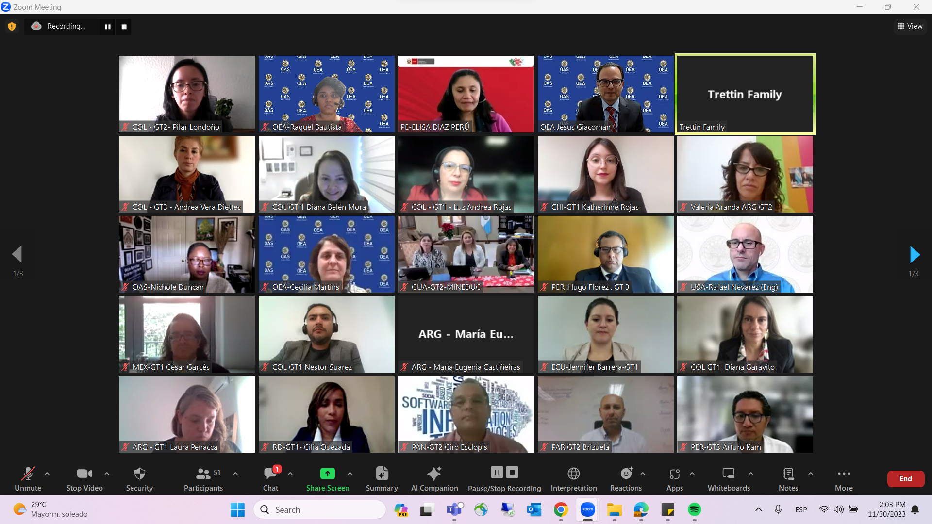

CIDED00348E01