**REUNIÓN DE PLANEACIÓN DE LAS AUTORIDADES** OEA/Ser.W/XIII.6

**CIDI Proceso Ministerial - Educación** CIDI/CIE/RPA/doc.17/23 rev.2 add.3

9 de febrero de 2023 14 junio 2023

Washington, D.C. Original: español

**2022-2025 WORK PLAN**

**OF THE INTER-AMERICAN COMMITTEE ON EDUCATION (CIE)**

**ANNEX III**

**HEMISPHERIC Program on healthy food and physical activity policies in school environments. A first line of action on fighting noncommunicable diseases in the Americas.**

**2022-2025 WORK PLAN**

**OF THE INTER-AMERICAN COMMITTEE ON EDUCATION (CIE)**

**ANNEX III**

**HEMISPHERIC Program on healthy food and physical activity policies in school environments. A first line of action on fighting noncommunicable diseases in the Americas.**

**Introduction**

Worldwide obesity has nearly tripled since 1975. In just 40 years the number of school-age children and adolescents with obesity has risen more than 10-fold, from 11 million to 124 million (2016 estimates). In addition, an estimated 216 million were classified as overweight but not obese1/. Available data show that, in the Americas, 33.6% of children and adolescents 5-19 years old are overweight and 14.4% are obese2/.

In comparison with other World Health Organization (WHO) Regions, the prevalence of overweight and obesity in adults is highest in the Americas (in 2016, 62% for overweight in both sexes and 28.6% for obesity, in adults over 18 years of age).

In the region, overweight in boys and girls under 5 years of age has been announced in the last 20 years. In 2020, the prevalence was 7.5%, 2 percentage points above the world average. South America exhibits the highest prevalence in this indicator (8.2%), followed by the Caribbean (6.6%) and Mesoamerica (6.3%).

In response to this epidemic, many countries in the Americas have sought to change norms and adopted regulations, including:

* Legislation and national policies to protect, promote and support breastfeeding practices, such as the implementation of the International Code of Marketing of Breast-milk Substitutes, the Baby Friendly Hospital Initiative, and maternity protection regulations;
* New school nutrition policies, with many focusing on improving the school food environment, particularly foods sold and served in schools, and the school physical activity environment;
* Improvements in national school feeding programs, as in the case of Brazil, Mexico, and others. For example, since [December 2020,](https://www.fnde.gov.br/index.php/centrais-de-conteudos/publicacoes/category/99-legislacao?download=14356%3Aresolu%C3%A7%C3%A3o-n%C2%B0-20%2C-de-02-de-dezembro-de-2020) Brazil requires a minimum of 23 natural or minimally processed foods per week for menus that provide three or more meals/day or meet 70% of daily nutritional needs. In school units that offer full-time school meals, the menus must offer at least 520g/students/week of fresh fruits and vegetables. And at least 75% of the budget must be allocated to the purchase of in natura or minimally processed foods;
* Promoting fiscal policies and front-of-package labeling and regulation of marketing of food to children;

1. <https://www.thelancet.com/journals/lancet/article/PIIS0140-6736(17)32129-3/fulltext#%20>
2. <https://www.who.int/data/gho>

* Other intersectoral areas such as family farming; and
* Promotion of physical activity through “open streets” programs.

Given this worrisome scenario in 2015 the Inter-American Task Force (IATF) on NCDs was launched at OAS Headquarters. This is a strategic alliance of inter-American organizations and associated international institutions and agencies led by the Pan American Health Organization (PAHO), to promote the prevention and control of noncommunicable diseases (NCDs) in the Americas through collaboration across various sectors of government. The IATF brings together the capacity and expertise of partner organizations working with different government sectors to reduce the burden of NCDs in the Americas.

The work of the IATF has proven to contribute to garnering greater political commitment for multi-sector interventions through the achievement of the adoption in 2018 of the Resolution [AG/RES. 2919 (XLVIII-](https://scm.oas.org/doc_public/ENGLISH/HIST_18/AG07745E03.doc) [O/18):](https://scm.oas.org/doc_public/ENGLISH/HIST_18/AG07745E03.doc) Strengthening multi-Sectoral responses to the crisis of Non-Communicable Diseases in the Americas by the General Assembly of the Organization of American States (OAS), which reinforces country commitments for a multi-sector NCD response. This resolution is expected to strengthen collaboration on NCDs at regional and country levels.

Promoting healthy school settings was raised as one of the proposed joint activities between PAHO and the OAS to introduce actions on school-based interventions in the Inter-American Education Agenda (IEA). The 2019-2022 Work Plan of the Inter-American Committee on Education (CIE) included as one of its projects the coordination with PAHO on the implementation of actions in the countries of the region for the promotion, monitoring, and evaluation of school environments conducive to prevention of non- communicable diseases in Latin America and the Caribbean*.*

Since its approval and through a Series of Policy dialogues held in 2020 and 2021, PAHO and the OAS have been working jointly to an open discussion and exchange of experiences related to actions on school- based interventions under the framework of the Inter-American Education Agenda. Appointed officials from both ministries of education and health discussed activities related to the implementation of the Plan of Action for the Prevention of Obesity in Children and Adolescents, on the promotion, monitoring, and evaluation of school environments conducive to healthy eating and physical activity.

Three virtual policy dialogues were held between 2020 and 2021. The first dialogue in November 2020 focused on the topic “Promoting school environments, healthy eating, and physical activity” while sharing experiences on the promotion, monitoring, and evaluation of school environments conducive to healthy eating and physical activity among representatives from the ministries of health and ministries of education. The second dialogue, “Promoting healthy life skills through physical and nutrition education in schools”, took place in June 2021. Officials shared their country’s public policies, programs, and recommendations for the promotion of healthy life skills and physical and nutrition education. Finally, the third dialogue was held in September 2021 and addressed the “Policies and programs on the promotion of regulations and standards for foods in the school environment”. Countries exchanged experiences, public policies, programs, and initiatives about the promotion, regulation, and control of the norms and actions for the availability, sale, and marketing of food in the school environment.

As part of the discussions, the importance of strengthening the education-health relationship was expressed as a priority area of action. There were concrete requests to:

* Strengthen intersectoral collaboration to provide a comprehensive and sustainable approach to the promotion of healthy living, ensuring inclusiveness and equity, especially for populations at more vulnerable conditions.
* Enhance sustainability of school feeding and healthy life practices, including physical activity, through the intersectoral and inter-institutional articulation, local territorial intervention approaches, and cultural relevance to effectively serve vulnerable populations.
* Strengthen regulations and standards to regulate food environments, including the school surroundings and food brought from home, improving the collaboration with families and communities and local producers and vendors.

More recently, at the Ninth Regular Meeting, held in November 2021, CIE Officials considered healthy school environments as one of the relevant axes for action under the framework of the Inter-American Agenda 2022-2027.

**The Inter-American Program on healthy food and physical activity policies in the school environment 2022-2025: goal and objectives**

With the return of children to schools after the COVID-19 pandemic, a school environment that enables healthy eating and physical activity is more important than ever. In this new phase of their collaboration and cooperative work, OAS and PAHO are moving one step forward by proposing a capacity building and technical assistance program. It aims to support countries who wish to advance their policy and programming in drafting plans, offer training and facilitate experiences and proven implementations on monitoring and evaluation on the topics at hand.

**Objectives**

* Create a space where countries can exchange successful initiatives to help to move forward the action framework and policies in their countries.
* Support a number of countries through south-south cooperation, technical assistance, and capacity building.
* Develop lessons learned and regional guidance on school environments for healthy food, nutrition, and physical activity:

**Themes and Areas of action**

* + Healthy school food environments.

All foods available in school environments should be healthy and nutritious and comply with WHO/PAHO recommendations and food-based dietary guidelines. This topic is linked to front-of-pack labelling laws, [PAHO’s Nutrient Profile Model,](https://iris.paho.org/bitstream/handle/10665.2/18621/9789275118733_eng.pdf) and the obesity prevention course.

* + Promoting physical activity through schools: [a toolkit](https://apps.who.int/iris/bitstream/handle/10665/350836/9789240035928-eng.pdf?sequence=1&isAllowed=y)

This topic relates to the promotion of physical activity trough schools in six domains: quality physical education, active travel to and from school, active before- and after- school programs, recess and recreation time, active classrooms and school curricula, and children with additional needs.

* + Action framework for developing and implementing public food procurement and service policies for a healthy diet.

[This action framework](https://www.who.int/publications/i/item/9789240018341) provides an overview of how to develop and/or strengthen, implement, assess compliance with, and evaluate, the effectiveness of a healthy public food procurement and service policy, including schools and linked to procurement of fresh foods from local farmers.

The core Areas of Action will be framed under the following:

|  |
| --- |
| **Research component:** |
| 1. Inventory of existing research and research institutions in related areas within the region. 2. Implemented programs on monitoring and evaluation. 3. Publication on priority topics identified withing the Inter-American Program implementation. |
| **Professional Development and Educational Resources component:** |
| 1. Regional distance course for teachers and school administrators: The Inter American Program on healthy food and physical activity policies in school environments. 2. Virtual Hub for policies, guidelines and tools on healthy food and physical activity policies in school environments. 3. Video and media series on healthy food and physical activity policies in school environments |

|  |
| --- |
| **Technical Assistance and Exchange Program:** |
| 1. Portfolio of Promising Initiatives and Policy Brief Series. 2. Technical Assistance missions and documentation of countries experiences. 3. Knowledge sharing workshops on policies and practices. |

**Methodology**

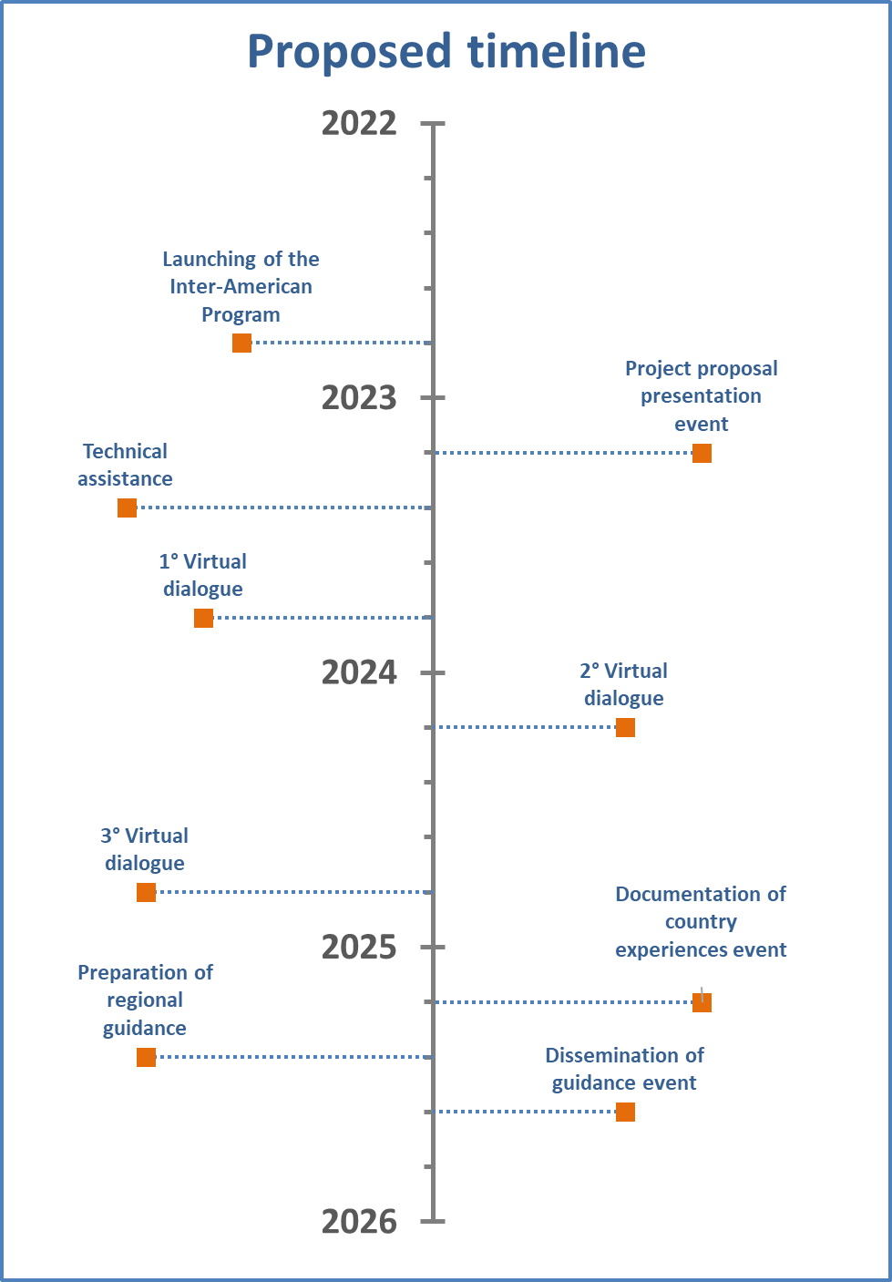

**Expected outcomes**

It is expected that at the end of 2025 at least three countries have been analyzed and/or strengthened policies to provide better school environments for healthy eating and physical activity.

**Human and financial resources**

The OAS and PAHO will make all its efforts to mobilize resources for implementation of this Inter-American Program, including effective and consistent contacts with potential donors. They will also seek to establish appropriate partnerships and fundraising efforts with various development organizations and relevant bodies of the Inter-American System, safeguarding such engagements against conflicts of interest.

**Designation of officials**

It is recommended that teams be made up of three officials responsible for public policies and programs about the subject and/or in charge of advising on topics related to healthy food and physical activity in their respective sector.

* Ministries of Education: [education@oas.org](mailto:education@oas.org) attention to Cecilia Martins.

CIDED00321E01