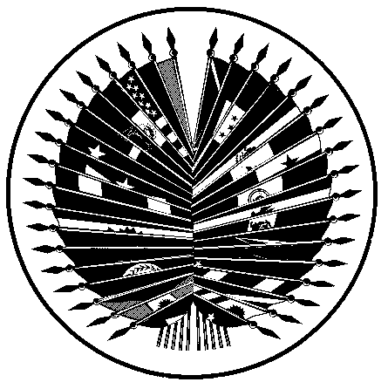

Memorandum
date June 28, 1977

SG/83/77

from: the Secretary General

to: Executive and Assistant Secretaries, Department and Office Directors, and Other Members of the Staff

subject: Format for Envelopes Using the Postal Frank in the United States

The United States Postal Service has brought to our attention, through the United States Permanent Mission, that envelopes being used for official mail of the Organization of American States have been produced in various formats, some of which do not conform to the Postal Regulations.

The prescribed format for official mail appears in Part 137 of the Postal Service Manual. An example is shown below. NO OTHER FORMAT IS AUTHORIZED.

An area 1-14 inches by 3 inches is reserved in the upper right corner for the indicia. The words "Postage and Fees Paid" must appear above the words "Organization of American States" to the left of the Postal Emblem in that corner. The mail piece must bear the complete return address, the words "Official Business" and the statement "Penalty for Private Use $300" in the upper left corner.

For other than first class mail, add the proper designation (second, third or fourth class, as the case may be) under "Postage and Fees Paid, Organization of American States" in the upper right corner.

All official OAS mail envelopes shall be printed with the frank as indicated below. To ensure full compliance with this directive, all official OAS mail, unless otherwise specifically authorized by the Secretary General, shall he handled through the Distribution Unit. Mail on which postage is paid (not mailed under the frank) may continue to be handled through the Message Center.


GENERAL SECRETARIAT POSTAGE AND FEES PAID
ORGANIZATION OF AMERICAN STATES ORGANIZATION OF AMERICAN STATES
Washington, DC 20006 U.S.A
OFFICIAL BUSINESS
PENALTY FOR PRIVATE USE $300

