GENERAL SECRETARIAT OF THE ORGANIZATION OF AMERICAN STATES



GUIDELINES FOR THE
COMPETITIVE BIDDING AND EVALUATION PROCESS

FOR PURCHASES EQUAL TO OR GREATER THAN $100,000

Established by the Contract Awards Committee in December 2013

Issued by the
Secretariat for Administration and Finance

Department of Procurement

TABLE OF CONTENTS

Section |  | Page
I. | Background and Scope of Application | 3
II. | Key Concepts | 3
III. | The Competitive Bidding Process for Purchases Equal to or Greater than $100,000 | 4
IV. | Contract Awards Committee Structure and Role in the Process | 4
 | A. CAC Structure | 4
 | B. CAC Procedures | 5
 | C. Requesting Dependency’s Role in the Process | 5
 | D. Department of Procurement’s Role in the Process | 6
V. | Evaluation Criteria and RFP Instructions
VI. | Contract Award Recommendation | 7
VII. | Award Decision and Contract Signature | 9
VIII. | Publication of the Award of Contract | 9
Annexes
A. | Bidding Process for Contracts Equal to or Greater than $100,000 | 10

I. Background and Scope of Application

1.1 GS/OAS’ Procurement Contract Rules 1.1.2, 4.3.2, and 5.1, modified by Directive No. 01/08 issued by the Secretary General on March 28, 2008, provide that all purchases “above $50,000” must be recommended for approval by the Contract Awards Committee. See Procurement Contract Rules and Directive No. 01/08 http://www.oas.org/legal/english/gensec/EXOR-00-01-CORR1.htm.

1.2 Procurement Contract Rule 10.2.2. a. governs the competitive bidding process for “Purchases Equal to or Greater than $100,000” and states that “[f]or each procurement likely to result in a contract price equal to or greater than $100,000, the GS/OAS shall publish a Request for Proposals ("RFP") which sets out the specifications for the goods or services desired and invites 5 or more qualified sources to submit written offers to provide those goods and services. The GS/OAS shall then negotiate with the qualified sources which reply as to the quality and quantity of the goods and services to be provided, their price, and other pertinent considerations, to the end of entering into the most desirable arrangement for the GS/OAS. Publication of the announcement of the RFP must be in the media (newspapers, trade journals, etc.); however, where the total contract sum is less than $300,000 or the Assistant Secretary for Management has certified that publication by media is not practicable for reasons of emergency or extraordinary urgency, then the publication requirement may be satisfied by mailing, faxing, or emailing a copy of the RFP to at least five qualified vendors known to the GS/OAS. All replies should be summarized on a permanent record, which should be signed by the person(s) receiving the bids.”

1.3 Procurement Contract Rule 10.2.2. b. governs the competitive bidding process for “Medium Purchases ($50,000 - $99,999)” and states that “[a] medium purchase is a procurement that has a contract price of more than $50,000 but not more than $99,999. For medium purchases, the GS/OAS may solicit written bids by mailing, faxing, or E-mailing the prospective vendors a bid sheet. A minimum of five qualified sources known to the GS/OAS should be contacted. The bidders may either mail or fax their bids to the GS/OAS; however, in those instances where: (1) the specifications are complicated; or (2) there are less than three vendors known to the GS/OAS within a two hundred-mile radius of where the goods or services are to be purchased, the GS/OAS shall employ the same procedures utilized for purchases equal to or greater than $100,000. All replies should be summarized on permanent record that should be signed by the person(s) receiving the bids.”

1.4 The procedures outlined in the Guidelines apply to “Purchases Equal to or Greater than $100,000”. The purpose of the Guidelines is to regulate the role of the Contract Awards Committee, the Department of Procurement and the Requesting Dependency during the procurement planning and the selection and evaluation process of this type of formal competitive bidding that public notice is required. However, the Guidelines shall be observed for “Medium Purchases ($50,000 - $99,999)” when applicable.

II. Key Concepts

For the purposes of these Guidelines, the following key concepts shall apply:

  - Contract Awards Committee: The CAC is responsible for recommending to the Secretary for Administration and Finance or to the Advisor to the Secretary General in Management the approval of all procurement contracts above $50,000.

  - Early involvement of DP in the process: The Requesting Dependency should consult with the DP on the upcoming procurement planning as soon as possible, especially for complex purchases. A formal request should be submitted at least five to eight weeks before the purchase is required.

  - Procurement Contract (Goods and Attendant Services): Is a contract for the purchase of supplies; materials; equipment, installation and maintenance; machines; vehicles; furnishings; printing and related services; transportation of people and goods; real property (as landlord or tenant); technical equipment and scientific materials; other goods and attendant services requested by areas and counterparts; insurance and bonds; buildings and grounds maintenance, construction, repairs, and renovation services.

  - Requesting Dependency: A requesting dependency is a dependency of the GS/OAS that requires the issuance of a procurement contract.

  - Responsive Bidder: A bidder is responsive if its proposal complies with the bidding instructions in accordance with GS/OAS’ terms and conditions of the bid set forth in the Request for Proposals (“RFP”).

  - Responsible Bidder: A bidder is responsible if it is able to satisfactorily perform the proposed work in compliance with the technical specifications outlined in the RFP.

  - Performance Contract “CPR” (Services): Is a contract for the purchase of services of a professional and/or administrative nature provided by consultants or independent contractors using their skills to: (a) produce a product, a result, or service required; (b) study, design, organize and/or manage projects; (c) advise and, when required, build capacity; (d) conference services.

CPRs are contracts for a limited time and for a specific result or purpose. CPRs are governed by the CPR Rules as per Executive Order 05-04 Corr. No. 1. These Guidelines are intended to explain the procurement contract process, not the CPR process. Although CPRs are controlled by the CPR Rules, the same competitive methods required of Procurement Contracts may be employed in awarding CPRs.

III. The Competitive Bidding Process for Purchases Equal to or Greater than $100,000

3.1 Purchases equal to or greater than $100,000 require review and recommendation by the CAC in order to ensure transparency and consistent application of the Procurement Contract Rules, specifically the competitive method outlined in Section 10.2.2 a. of the Procurement Contract Rules shall be followed.

3.2 The role of the CAC in the competitive bidding process for purchases equal to or greater than $100,000 is outlined below. Also, Annex A includes a flowchart on the procurement planning and the selection and evaluation process of this type of formal competitive bidding.

IV. CAC Structure and Role in the Process

A. CAC Structure

4.1 The CAC is comprised of:

- The Chair,
- A representative of the Department of Legal Services, and
- A representative of the Requesting Dependency.

4.2 The Chair shall be appointed by the Secretary for Administration and Finance. The Secretary for Administration and Finance shall also appoint an Alternate Chair who will intervene in the absence of the Chair. Once the Chair is replaced, he/she can return to the process as an alternate. The Chair and the Alternate Chair should be staff members from a Secretariat different from the Secretariat for Administration and Finance. The term of office for the Chair and the Alternate Chair shall be one (1) year. Their appointments may be renewed. On expiry of their term of office, the Chair and the Alternate Chair shall remain in office until they are replaced or until their appointments are renewed.

4.3 The representatives of the DLS and the Requesting Dependency are appointed by the Directors or officers of equivalent rank of the Dependencies they represent.

4.4 The Department of Procurement shall serve as the Technical Secretariat of the CAC.

4.5 On occasion, representatives from other areas in the GS/OAS, such as the Office of the Inspector General, may also attend and participate as an observer in the CAC meetings.

B. CAC Procedures

4.7 The CAC’s role is to ensure that competitive methods have been employed transparently in contract awards equal to or greater than $100,000. Therefore, after bids have been received in competition for a procurement contract, the CAC is convened for a bid opening meeting to make sure that all bids are opened and recorded simultaneously.

4.8 During the bid opening meeting, the CAC members:
- Open, date and sign the proposals submitted by the bidders.
- Identify and read out loud, when possible, the price proposed by the bidders.
- Provide the bids to the Requesting Dependency for review and recommendation.
- Determine whether there has been a lack of competition, or bids are not substantially responsive, and decide to reopen the bidding process. Before inviting new bids, the CAC may request the Requesting Dependency and/or DP to revise the technical specifications, the scope of the contract, or a combination of both.
- In determining responsiveness, verify whether the bidders have advertised use of internationally accepted standards in their proposals as requested by the RFP, if applicable.

4.9 After the bid opening meeting, the CAC members:
- Meet (virtual and/or live), when necessary, to request additional information, to consider all relevant material or to discuss questions raised on the bidding process.
- Approve the bid opening minutes drafted and circulated by DP.
- Review the Aide Memoire prepared by DP, containing the Requesting Dependency’s and DP’s analysis.
- Request additional information and clarifications from the Requesting Dependency or DP, if necessary.
- Recommend to the Secretary for Administration and Finance or to the Advisor to the Secretary General in Management,the approval of the procurement contract.

C. Requesting Dependency’s Role in the Process

The Requesting Dependency should follow the following guidelines:

4.10 Proactively consults with the DP on the upcoming procurement planning early in the process in order to determine the actions and timeline required to be taken to complete the purchase.

4.11 Submits a formal request to the DP at least five to eight weeks before the purchase is required, depending on the complexity of the purchase.

4.12 The formal request consists of a brief description and goals of the project and a detailed description of the goods and/or services to be obtained, including the technical specifications. DP is available to assist with the preparation of this request.

4.13 Provides the DP with a list of potential suppliers (including contact name, address, telephone and fax numbers, and e-mail address) and/or allows the DP sufficient time to research potential vendors to be added to the list.

4.14 Participates in the CAC bid opening meeting, as a member of the CAC.

4.15 Analyzes and evaluates the proposals received. This written evaluation shall contain the following:

- Analysis of the technical capability, competency, price, and quality of work or product, preferably in chart format using a weighted point system.

- Reasons to support any recommendation to select or disqualify a bidder. However, it should be noted that the CAC makes the final recommendation to the Secretary for Administration and Finance or to the Advisor to the Secretary General in Management for their approval of the purchase, as per Section 6.3 of the Guidelines.

4.16 Submits to the DP its technical analysis and evaluation recommending the most qualified bidder.

D. DP’s Role in the Process

As the Technical Secretariat to the CAC, the DP provides technical advice and administrative support to the CAC, as follows:

4.17 Assists the Requesting Dependency in preparing the RFP and the bid package for upcoming bidding process.

4.18 Solicits written proposals by mailing, or E-mailing a minimum of five prospective vendors.

4.19 Publishes the RFP on the OAS Web Page under “Procurement Notices” for a minimum of ten (10) business days, and on the dgMarket Web Page under “Tenders”, and any other web sites that would facilitate a wider distribution of the RFP.

4.20 Sets a date when questions from prospective bidders are to be received by DP.

4.21 Provides answers to procurement questions submitted by prospective bidders. DP may require the assistance of the Requesting Dependency if a technical request for clarification is submitted by a prospective bidder.

4.22 Releases in writing all answers to all prospective bidders.

4.23 Receives and records the bids received in preparation for the CAC bid opening meeting.

4.24 Coordinates and participates in the CAC bid opening meeting, as the Technical Secretariat to the CAC.

4.25 After the CAC bid opening:
- Prepares and circulates for the CAC members review the draft minutes of the CAC bid opening meeting.
- Verifies that bids were “responsive” to the technical requirements.
- Conducts reference checks of potential bidders.
- Requests the review of audited financial reports of potential bidders from the Department of Financial and Administrative Management Services.
- Requests Best and Final offers only if time permits and is in the best interest of the Organization.
- After receiving the Requesting Dependency’s recommendation, evaluates its recommendation in order to verify that the evaluation criteria as set forth in the RFP was applied in the analysis of the proposals, and prepares an Aide Memoire including the DP’s analysis and summarizing the CAC Award Recommendation.
- Notifies the contract award to the selected bidder and non-selected bidders and publishes the name of the selected bidder by posting an announcement on the OAS Web Page under “Procurement Notices” and on the dgMarket Web Page under “Contract Awards” within 3 business days after the Secretary for Administration and Finance or the Advisor to the Secretary General in Management approves the award recommendation made by the CAC..
- Conducts post contract award activities such as assisting the CAC during the negotiations of the terms of the contract with the recommended bidder before the award is granted.

V. Evaluation Criteria and RFP Instructions

  - The RFPs shall clearly state the factors that will be considered in evaluating proposals and selecting a source. The purpose is to provide prospective bidders with information on which evaluation factors the GS/OAS believes to be most important in satisfying the GS/OAS procurement objectives. Evaluation factors should be tailored to each acquisition by the Requesting Dependency and DP.

  - Types of Evaluation Factors:
- Cost or price, and
- Technical factors, such as:
- Innovations and enhancements
- Process or techniques to be used
- Key personnel
- Schedule compliance
- Relevant experience or past performance
- Technical and management plans (work plan)

  - In competitive procurements the tradeoff analysis decisional rule should be applied whereby the Requesting Dependency evaluates both price and technical factors and awards the contract to the bidder proposing the combination of factors which offers best value to the GS/OAS. Therefore, the award decision is made by comparing the marginal differences in price with the marginal differences in the other evaluation factors.

  - At a minimum, the RFP must list all evaluation factors that will affect the contract award and also indicate the decisional logic that the GS/OAS intends to use to make the selection decision. As regards the decisional logic, the RFP shall state whether all technical factors, when combined, are: i) significantly more important than cost or price, ii) approximately equal in importance to cost or price, or iii) significantly less important than cost or price.

  - The same evaluation criteria should be applied to all proposals and should remain unchanged through the procurement process.

  - RFP must ask for those submissions for the purpose of evaluation and/or verification of the minimum requirements. The evaluation factors specified in the RFP serve as the basis for determining what is to be submitted by bidders.

  - Only when it is necessary for a particular acquisition or class of acquisitions, DP, with the assistance of the Requesting Dependency, develops special standards of responsibility, such as international accepted standards. In those cases, the international accepted standard should always be indicated in the RFP and should apply to all bidders. Also, the RFP shall request to all bidders to advertise in their respective proposals the use of the internationally accepted standard.

VI. Contract Award Recommendation

6.1 The CAC’s recommendation to award a contract is summarized in an official Aide Memoire prepared by the DP. In signing the Aide Memoire, the CAC members acknowledge the procurement process and make a recommendation to the Secretary for Administration and Finance or to the Advisor to the Secretary General in Management for the approval of the procurement contract, as per Section 6.3 of the Guidelines. A CAC member who dissents or otherwise has concerns regarding the procurement is obligated to state the reasons for such dissent or concern in the Aide Memoire.

6.2 The Aide Memoire should follow the format as detailed below and contain the minimum information on the goods and/or services to be procured:

1. Background/History

This section contains the following information:
- Name of the Requesting Dependency.
- Brief description and goals of the project.
- Reason for the request.
- Detailed description of the goods or services to be obtained, including the technical specifications.

2. Actions taken/Process followed

This section includes an explanation of the actions taken, including but not limited to the following:
- Names and number of bidders invited to participate in the bidding process.
- Date on which the RFP was sent to the bidders, the date of RFP posting on the OAS Web Page under “Procurement Notices”, and the RFP’s closing date.
- Number of responses received and from which companies.
- Price summary submitted by each company.
- Actions taken by the CAC at the bid opening meeting, including whether it met to open the bids, requests for additional information and/or Best and Final Offers, criteria set for reviewing the bids, what the Requesting Dependency was asked to do by the CAC, etc.

3. Technical Analysis, Evaluation and Recommendation

This section contains the technical analysis, evaluation and award recommendation submitted by the Requesting Dependency to the DP.

4. Recommendation to the CAC by the DP

This section includes the DP analysis and recommendation to the CAC and is based on compliance with the Procurement Contract Rules.

5. Award Recommendation by the CAC

This section is the CAC’s recommendation on the contract award to the Chief of Staff and/or to the Secretary for Administration and Finance based on the review and analysis provided by the Requesting Dependency and DP, and shall include any CAC member’s dissent or concerns regarding the procurement.

6.3 Final Decision on the Contract Award

The General Standards authorizes the Secretary General to negotiate, award, and execute procurement contracts. This authority under the Procurement Rules has been delegated to the Secretary for Administration and Finance. As stated in Chapter III - Authority to Contract of the Procurement Contract Rules, and by delegation in Section 3.2, the Secretary for Administration and Finance may negotiate, award, and execute all procurement contracts. By delegation in Section 3.7.1, the Director of DP shall have authority to negotiate, award, execute, and administer procurement contracts.

In practice the authority for the final decision on the contract award for procurement contracts before the CAC is as follows:

(a) The Secretary General or the Advisor to the Secretary General in Management shall make the final decision for dollar amounts of $300,000 and above.

(b) The Secretary for Administration and Finance shall make the final decision for contract awards for dollar amounts from $100,000 through $299,999.

(c) The Director of DP shall make the final decision for contract awards for dollar amounts from between $50,000 through $99,999. In those limited situations where DP is at the same time the Requesting Dependency as well as the Technical Secretariat, the Secretary for Administration and Finance shall make the final decision.

VII. Award Decision and Contract Signature

7.1 Once the Advisor to the Secretary General in Management, or Secretary for Administration and Finance has approved and signed the Aide Memoire, as per Section 6.3 of the Guidelines, the DP sends an award letter to the winning company and the non-award letters to unsuccessful bidders.

7.2 An approved requisition for the estimated dollar amount of the purchase must be prepared and sent to the DP prior to the approval of the CAC’s recommendation contained in the Aide Memoire. A purchase order must be issued and the contract fully executed prior to the commencement of the services or commitments of the GS/OAS’ financial resources. See Directive No. 01/05 issued by the Secretary General on September 30, 2005 http://www.oas.org/legal/english/Directives/SG012005.pdf.

VIII. Publication of the Award of Contract

8.1 DP is responsible for publishing the name of the selected bidder by posting an announcement on the OAS Web Page under “Procurement Notices” and on the dgMarket Web Page under “Contract Awards” within 3 business days after the Secretary for Administration and Finance or the Advisor to the Secretary General in Management approves the award recommendation made by the CAC.

  - In the non-award letters sent to unsuccessful bidders, the DP will inform bidders that any bidder who wishes to know the results of the bidding process may do so by visiting the OAS Web Page under “Procurement Notices” and the dgMarket Web Page under “Contract Awards.” Any request for further information shall be sent to the DP.
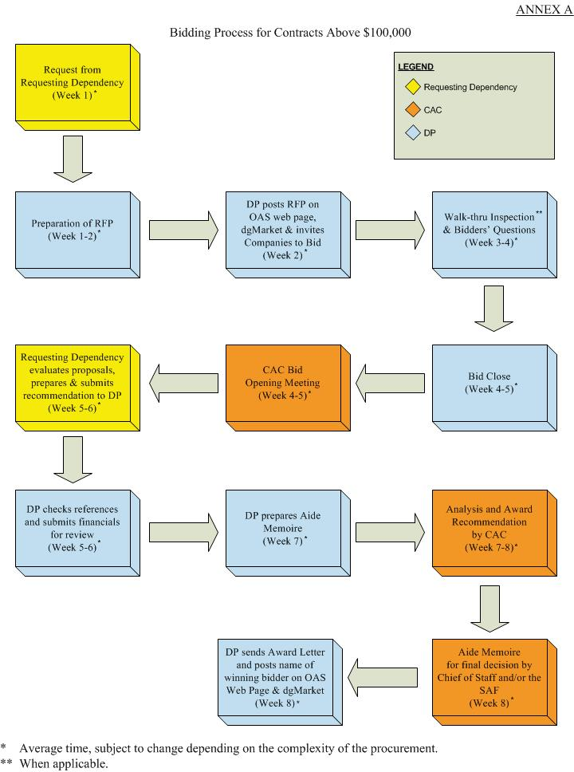

dgMarket is an online tender information service and turnkey solution developed by the Development Gateway Foundation, a non-profit organization that provides Web-based tools to make aid and development efforts more effective.

